**Working**

**together for accessible**

**transport**

Feedback from transport professionals and stakeholders

Full Report, November 2024

This report is part of a series of research conducted by the National Centre for Accessible Transport (ncat) since its launch as an Evidence Centre in early 2023. Whilst this is a standalone report, we would recommend it is considered alongside other ncat research published from late 2024. As ncat progresses further, reports and insights will also be published on our website [www.ncat.uk](https://www.ncat.uk)

ncat encourage you to freely use the data available in this report for your research, analyses, and publications. When using this data, or quoting any comments, please reference it as follows to acknowledge ncat as the source:

‘ncat (2024). ‘Working together for accessible transport’. Available at [www.ncat.uk](https://wsp-uk.shinyapps.io/ncat_dashboard/www.ncat.uk)

## Contents

Contents 2

Highlights 3

1 Why did we do this work? 5

2 What did we do, how did we do it, and who did we work with? 6

3 What did we find? 8

3.1. Finding: Transport decisions and policies lack input from lived experiences 9

Key findings: 9

Knowledge and understanding barriers: 10

Knowledge and understanding opportunities for improvement: 11

3.2. Finding: Accessibility improvements are seen to be too expensive, and it can be difficult to justify the investment 12

Key findings: 12

Financial barriers: 13

Financial opportunities for improvement: 14

3.3. Finding: Physical limits of buildings and existing infrastructure are seen as barriers to improving accessibility 15

Key finding: 15

Built environment barriers: 15

Built environment opportunities for improvement: 16

3.4. Finding: The transport sector lacks a joined-up approach to accessibility 17

Key findings: 17

Accountability and ownership barriers: 18

Accountability and ownership opportunities for improvement: 19

4 What conclusions did we come to? 20

5 What should happen next? 21

We have made recommendations for people in the transport and policy sector: 21

We have made recommendations for ncat and its future activities: 22

6 About ncat 23

7 References 24

8 Terms used in this report 24

## Highlights

The document explores ways to improve accessible transport in the UK. It uses feedback from people working in the transport sector to identify things that hinder progress towards accessible transport, and opportunities for change.

We collected feedback from 173 transport sector representatives through surveys, group discussions, and focus groups. These people work in public and private transport organisations and shared their insights on barriers to and opportunities for improving transport accessibility.

The document lists four key themes from this feedback:

* **Knowledge and understanding**: Transport decisions and policies lack input from lived experiences. Transport professionals often mentioned this issue, with 43% of responses highlighting it.
* **Financial**: Accessibility improvements are seen to be too expensive, and it can be difficult to justify the investment.
* **Built environment**: Physical limits of buildings and existing infrastructure are seen as barriers to improving accessibility.
* **Accountability and ownership**:The transport sector lacks a joined-up approach to accessibility.

The document discusses ways to address these themes, including increasing the representation of disabled people in decision-making, embedding accessibility into transport policies, highlighting the economic benefits of accessible transport, and clarifying accountabilities across the transport sector.

## 1 Why did we do this work?

Research from the Motability Foundation has shown that disabled people take 38% fewer trips than non-disabled people. This has not improved for over a decade. More research is needed to understand why this has not improved.

The UK has a complex transport system. It has public and private organisations, and 1.5m employees.[1] This document uses feedback from transport professionals about ways to make transport more accessible.

We aimed to get feedback from transport professionals at all levels: local, regional and national, and with different levels of seniority. They are from the public, private and non-profit sectors.

A limitation of this work is that does not include equal responses from all transport industry representatives. For example, only one respondent worked in the air transport / aviation sector. Further research could seek feedback from a wider audience in the transport sector, such as customer service staff, and from more disabled people that work in the transport sector.

## 2 What did we do, how did we do it, and who did we work with?

This report looks at the issues and barriers identified by those working in the transport sector. It examines their limits and opportunities to improve transport accessibility.

We held six feedback sessions with transport sector representatives. 173 people provided feedback through the following events:

* Four focus groups with a total of 46 individuals.
* Two surveys with a total of 127 individuals.

The feedback sessions included representatives from various groups. These groups were combined authorities, county councils, local councils, transport authorities, technology providers, consultants, and operators in rail, bus, aviation, and micromobility.

They were selected from ncat’s existing working relationships, transport representatives from the [Community of Accessible Transport (CAT) panel](https://www.ncat.uk/get-involved/join-our-panel/), and targeted outreach. Invitations were sent to participants over email.

Transport sector representatives were asked to provide their feedback about the following focus areas:

* What does your organisation already do to make transport accessible?
* What challenges do you or your organisation face in improving transport accessibility?
* What changes do you think could help improve transport accessibility?
* What could you do in your role to make transport more accessible?

Discussion prompts were displayed on the screen and read aloud, and responses were gathered verbally, via the Chat function and through online data feedback tools.

The feedback gathered was analysed using thematic analysis. We categorised the comments by theme and topic for this report, highlighting the things that are hindering progress, and opportunities for change.

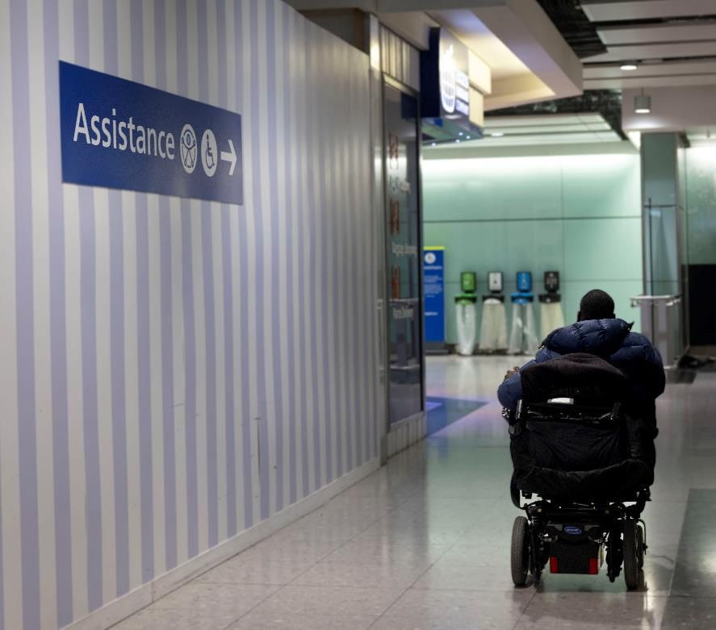

Image - (c) ncat

## 3 What did we find?

Transport sector workers asked during this study provided 240 unique comments on the topic of accessible transport. The comments were categorised by theme. The main themes that were identified from this feedback were:

* Knowledge and understanding
* Financial
* Built environment
* Accountability and ownership

The highest number of comments related to the ‘knowledge and understanding’ theme.

**Table 1. Themes from comments by transport professionals, by number and proportion of responses.**

|  |  |
| --- | --- |
| **Theme** | **Responses** |
| **Knowledge and understanding**: Transport decisions and policies lack input from lived experiences. | 42.9% of responses,  103 comments |
| **Financial**: Accessibility improvements are seen to be too expensive, and it can be difficult to justify the investment. | 22.5% of responses,  54 comments |
| **Built environment**: Physical limits of buildings and existing infrastructure are seen as barriers to improving accessibility. | 19.6% of responses,  47 comments |
| **Accountability and ownership**:The transport sector lacks a joined-up approach to accessibility. | 15.0% of responses,  36 comments |

## 3.1. Finding: Transport decisions and policies lack input from lived experiences

42.9% of comments (103 in total) highlighted the need for better understanding or guidance to embed accessibility into transport projects. Feedback fell into two areas.

### Key findings:

* There isn’t clear policy and design guidance about accessible transport for transport professionals.
* There is a lack of understanding of lived experiences in the transport sector.

**Table 2. Comments from transport professionals about ‘knowledge and understanding’, by proportion of responses**

|  |  |
| --- | --- |
| **Sub-topics related to ‘knowledge and understanding’**  (n=103 comments/phrases) | **Percentage**  (% of total comments mentioning this topic) |
| Policies, guidance and information about barriers and what works | 14.6% |
| Engagement with disabled people / users | 13.8% |
| Training / learning | 9.6% |
| Internal culture / attitudes | 3.8% |
| Workforce representation | 1.3% |
| **Percentage of total comments, related to knowledge and understanding** | 42.9% |

### Knowledge and understanding barriers:

* **There isn’t clear policy and design guidance about accessible transport for transport professionals:** A lack of laws and guidance was seen as a barrier to understanding by both public and private sector bodies.

Conflicting design guidance can be an issue for transport professionals. One respondent noted, “***Design standards sometimes contradict each other, and it can become more complex once contractors are involved in delivering projects.”***

Additionally, a rail operator highlighted that rail replacement buses in England sometimes fail to meet the Public Service Vehicles Accessibility Regulations 2000 (PSVAR). Meanwhile, an air transport company noted a lack of government guidance on accessibility. They also mentioned having limited control over aircraft design.

* **There is a lack of understanding of lived experiences in the transport sector:** Respondentssee engaging with disabled people as crucial to improving transport.

Feedback from the public and private sector supports this. One local authority respondent noted it is difficult “finding local groups or specific users to engage (with)”. Meanwhile, a micromobility operator commented that they have “limited understanding of user needs”. Some organisations have user groups or panels, but these are not always used on all transport projects.

Designing for diverse needs can be challenging. One respondent noted it is “difficult to design for all." Another stressed the need to consider the entire journey.

### Knowledge and understanding opportunities for improvement:

Transport sector employees identified ways that they could better understand accessible transport:

* **Work with disabled people**: Many felt engaging with disabled people is key. One respondent said, "if you don’t ask, you’ll never find out."
* **Look at what’s needed to provide training**: There is a clear demand for better training about accessible transport. One public sector representative suggested to, ***“learn more about it to understand (the) changes that we can make.”***
* **More diverse decision-makers:** Severalpeoplecommented on the need for a more diverse workforce. They also seek more disabled people in decision-making roles. One bus operator shared that having a disabled employee in a top role brought positive change.
* **Set clear accessibility standards**: Respondents wanted better guidelines and policies for accessibility. This would support improvements and reduce inconsistency across the sector. One bus operator suggested the need for “common standards for accessibility, so there is no need to have different bus specifications in different local authorities.”

## 3.2. Finding: Accessibility improvements are seen to be too expensive, and it can be difficult to justify the investment

22.5% of comments (54 in total) identified budgets and finances as a key barrier in accessible transport decisions.

### Key findings:

* There is a lack of budget or long-term funding certainty in the transport sector.
* The economic benefits of investing in transport accessibility or social value are not understood.

**Table 3. Comments from transport professionals about ‘finance’, by proportion of responses**

|  |  |
| --- | --- |
| **Sub-topics related to ‘finance’**  (n=54 comments/phrases) | **Percentage**  (% of total comments mentioning this topic) |
| Cost / budget allocations / competing budgetary requirements | 13.8% |
| Business case / cost-benefit analysis | 8.8% |
| **Percentage of total comments, related to finance** | 22.5% |

### Financial barriers:

* **There is a lack of budget or long-term funding certainty in the transport sector**: Respondents cited budget limits and competition for funding as obstacles to investing in accessible transport. One local authority representative stated that they have, “Scarce resources and competing funding needs”. Another stated that their accessible travel programme had been cancelled due to organisational funding constraints.

One local authority mentioned the difficulties of applying for funding and stated that they have waited over a year for a response to an application to access a source of government funding.

* **The economic benefits of investing in transport accessibility or social value are not understood**: Many struggled to quantify the benefits of accessibility upgrades, making it hard to advocate for such investments.

Several public sector representatives said investment decisions rely on business cases. They said that making projects more accessible can be more costly, which can reduce the chance of funding. One remarked, “Every person is equal in a cost-benefit analysis. We don’t account for people that don’t have an alternative [means of transport].”

Another stated that public sector key performance indicators do not support accessibility improvements.

Private sector representatives echoed these sentiments. A bus operator stated, “Commercial imperatives override social considerations”.

### Financial opportunities for improvement:

Transport professionals suggested actions to close the accessibility gap:

* **Highlight economic benefits**: Participants emphasised the need for evidence of the value of investments in accessibility. Public sector representatives wanted evidence that accessibility projects offer value, especially regarding trips and income. One noted, ***“We overlook the economic benefit of access.”***

This was echoed by bus and rail operators. They wanted to know how quickly improvements would boost ridership. One bus operator highlighted the need for evidence showing how upgrades could save time, such as in "dementia-friendly design."

* **Link funding to accessibility**: A suggestion was made to tie public sector funding to the accessibility of projects. One person stated, “Local authorities should withhold funding for schemes unless they demonstrate accessibility.”

## 3.3. Finding: Physical limits of buildings and existing infrastructure are seen as barriers to improving accessibility

19.6% of comments (47 in total) identified physical, infrastructure or technological constraints as a restriction in improving transport accessibility.

### Key finding:

* The built environment and existing infrastructure can create physical constraints to improving transport accessibility.

**Table 4. Comments from transport professionals about the ‘built environment’, by proportion of responses**

|  |  |
| --- | --- |
| **Sub-topics related to ‘built environment’**  (n=47 comments/phrases) | **Percentage**  (% of total comments mentioning this topic) |
| Physical environment | 8.3% |
| Physical infrastructure | 5.0% |
| Implementation challenges | 4.2% |
| Digital infrastructure | 2.1% |
| **Percentage of total comments, related to the built environment** | 19.6% |

### Built environment barriers:

* **The built environment and existing infrastructure can create physical constraints to improving transport accessibility:** Some respondents cited space and historic constraints as barriers. Public sector representatives particularly noted this issue. For example, a combined authority representative mentioned difficulty in widening cycle lanes for different mobility aids, while navigating market stalls and outdoor seating.

Others pointed out that narrow pavements, different gradients and on-street parking worsen accessibility.

A rail operator noted that they had challenges with an old, listed building. Meanwhile, a bus operator noted the difficulty in providing accessible routes to bus stops in rural areas.

### Built environment opportunities for improvement:

Despite the challenges, transport sector professionals see two key opportunities:

* **Better legislation and guidance:** Respondents believe improved laws and guidance are crucial. Low Traffic Neighbourhoods was referenced as a step in the right direction in terms of guidance on active travel standards. One respondent stated that they would value a similar publication that focused on accessibility.
* **More community engagement early into transport projects**: Some respondents stressed the need for better engagement during physical transport projects. Some said they believe involving disabled people and disabled persons organisations from the start is vital. One local authority representative said, "More disabled people should be involved in design work."

## 3.4. Finding: The transport sector lacks a joined-up approach to accessibility

15.0% of comments (36 in total) cited accountability and ownership of decision-making as barriers. Feedback fell into three areas.

### Key findings:

* Transport sector decisions are driven by central policies.
* There are not clear accountabilities for accessible transport.
* There is not a collaborative or standard approach to accessibility across the transport sector.

**Table 5. Comments from transport professionals about ‘accountability and ownership’, by proportion of responses**

|  |  |
| --- | --- |
| **Sub-topics related to ‘accountability and ownership’**  (n=36 comments/phrases) | **Percentage**  (% of total comments mentioning this topic) |
| Policy direction | 7.1% |
| Roles and responsibilities (across the end to end journey) | 5.0% |
| Collaboration in the sector | 2.9% |
| **Percentage of total comments, related to accountability and ownership** | 15.0% |

### Accountability and ownership barriers:

* **Transport sector decisions are driven by central policies**: Policies, and politics shape transport services. Public bodies said they must follow strategies and plans at all levels. This influences accessible transport. Respondents also noted that accessibility isn't prioritised like health and safety.
* **There are not clear accountabilities for accessible transport**:Some respondents said that decisions are beyond their control. A public authority cited the lack of national (governmental) coordination of accessibility as a major barrier. Another pointed out that the limited decision-making power of local authorities hampers improvements and efficiency.

Some public sector respondents believe private companies should be more accountable. For example, one local authority member said, “Utility companies and similar groups disrupt the street design and do not restore it after works”. Another suggested developers should ensure that transport to new housing developments is accessible.

* **There is not a collaborative or standard approach to accessibility across the transport sector**: Respondents noted the absence of a standard approach or direction as a barrier. Public authorities and non-profits called for better collaboration and consistency across the sector. This includes consistency across geographical boundaries and across different modes of transport. One suggested sharing best practices to improve accessible transport.

Some private sector participants echoed this sentiment. They stressed the need for collaboration and consistency in standards and guidance. This approach would avoid issues noted in the responses, with one bus operator stating, “Without having an approach that is joined up across county boundaries we won't have an accessible network.”

### Accountability and ownership opportunities for improvement:

Transport sector representatives proposed a key idea to improve accessibility.

* **Define roles, improve collaboration and share knowledge:** The need for a consistent approach to transport accessibility was suggested. One representative suggested a national policy group for accessible transport. Another called for a panel that spans sectors and industries. This would ensure a comprehensive approach to accessibility.

The sharing of knowledge, evidence and data was also suggested, as a central source of information. This was suggested as something that could help multiple organisations understand how and where people want to travel, and how to make improvements.

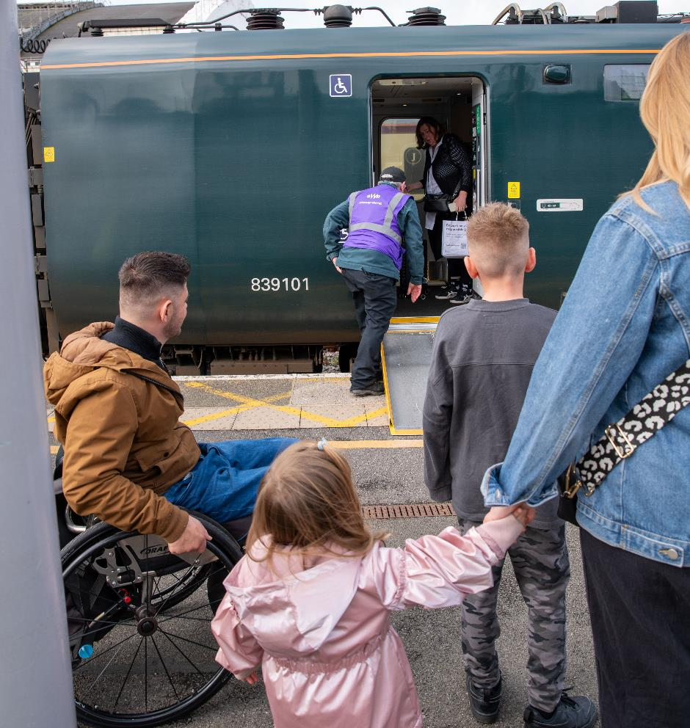

Image - (c) ncat

## 4 What conclusions did we come to?

This document identifies obstacles to improved transport accessibility in the UK and proposes solutions, as suggested by transport professionals.

It draws on feedback from transport representatives to pinpoint four main issues that are seen to be hindering progress: **knowledge and understanding, financial, the built environment, and accountability and ownership.**

It summarises suggestions to overcome these issues. Ideas include increasing representation of disabled people in transport decision-making, making accessibility a priority in policies, showcasing the economic benefits of accessibility, and improving collaboration in the transport sector.

The report demonstrates that people working in the transport sector face obstacles and barriers that hinder improvements in transport accessibility. Those that participated in the research often had a desire to make transport access better but were hindered by factors such as knowledge and budgets. Recommendations have been made, which are summarised in the next section.

## 5 What should happen next?

Many people that participated in the research want to make transport more accessible. Their ideas were turned into recommendations. These aim to improve transport access for disabled people.

### We have made recommendations for people in the transport and policy sector:

* **Get more disabled people into transport jobs and decision-making positions**. Review how your organisation recruits staff and speak to disabled people to understand how to make your organisation more inclusive.
* **Establish strong leadership for accessible transport**. Appoint a senior person in national governments as an accountable lead for accessible transport. This individual should be responsible for overseeing accessibility across all modes of transport and be responsible for holding transport organisations to account.
* **Align public funding with accessibility.** The government should ensure that transport projects receive public funding only if they prioritise accessibility. In the research, several people pointed out that accessibility is not viewed as essential as health and safety.
* **Create standard regulations and guidance about accessible transport.** Develop clear regulations and tools that people that work in the transport sector can use to embed accessibility in their work, whether that is a policy, or an operational service. These should be co-produced with disabled people and provide common standards that apply to all local authorities.

### We have made recommendations for ncat and its future activities:

* **Conduct research into the economic benefits of accessible transport**. Provide evidence that transport professionals can use to secure funding for improvements.
* **Look at what’s needed to train transport employees about how to meaningfully co-produce projects with disabled people.** Provide guidance and tools to help people in the transport sector co-produce projects with disabled people.
* **Create a forum and database for sharing knowledge across the transport sector.** Create ways for people to share knowledge and best practice across the transport sector and share national and international examples of things that work in different locations.

## 6 About ncat

The National Centre for Accessible Transport (ncat) works as an Evidence Centre developing high quality evidence, best practice, and innovative solutions to inform future disability and transport strategy, policy, and practice by:

* Engaging with disabled people to better understand their experiences and co-design solutions
* Amplifying the voices of disabled people in all decision making
* Collaborating widely with all transport stakeholders
* Demonstrating good practice and impact to influence policy

ncat is delivered by a consortium of organisations that includes Coventry University, Policy Connect, The Research Institute for Disabled Consumers (RiDC), Designability, Connected Places Catapult, and WSP. It is funded for seven years from 2023 by the Motability Foundation.

For more information about ncat and its work please visit [www.ncat.uk](http://www.ncat.uk)

To contact ncat, either about this report or any other query, please email [info@ncat.uk](mailto:info@ncat.uk)

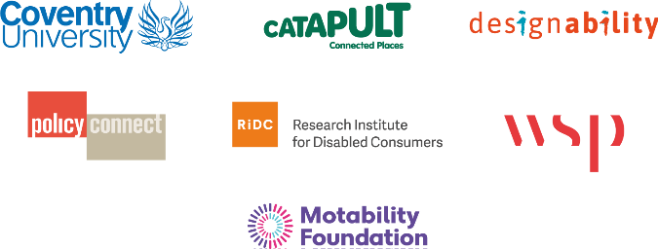

## 7 References

* [Motability Foundation, The Transport Accessibility Gap The opportunity to improve the accessibility of transport for disabled people (2022).](https://www.motabilityfoundation.org.uk/media/iwaidhxk/motability_transport-accessibility-gap-report_march-2022_final.pdf)

## 8 Terms used in this report

* **Combined authorities**: A legal body set up by two or more local authorities in England to undertake joint functions.
* **Community of Accessible Transport (CAT) Panel**: A panel of disabled people with lived experiences, transport representatives and interested parties.
* **Cost-benefit-analysis (CBA):** An approach to assess the economic advantages and disadvantages of a project or policy.
* **Local authorities**: An administrative body responsible for local government in a specific area.
* **Low Traffic Neighbourhoods:** A guidance document for active travel (walking, cycling, wheeling) design.
* **Micromobility**: A category of small, lightweight vehicles, such as bicycles and electric scooters, used for short trips.
* **National Centre for Accessible Transport (ncat):** An organisation established to make transport accessible for all.
* **Streetscape**: The way a street looks and is designed, considering the transport services, buildings, landscaping.
* **Transport accessibility gap:** The difference in the number of trips taken by disabled people compared to non-disabled people.
* **Transport authorities:** Organisations responsible for the planning, coordination, and management of transport services within a specific area.
* **Transport operators:** Companies that provide transport services to the public, such as bus, rail, and aviation companies.

1. [Number of people employed in the transport and storage industry from 1st quarter 1997 to 3rd quarter 2024](https://www.statista.com/statistics/1385961/uk-transport-workforce/%23:~:text=Number%20of%20people%20employed%20in%20transport%20and%20storage%20UK%201997%2D2023&text=As%20of%20the%20fourth%20quarter,the%20first%20quarter%20of%201997.)