Understanding and identifying barriers to accessing transport

The experiences of disabled people in the UK

Full Report, November 2024

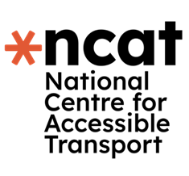

This report is part of a series of research conducted by the National Centre for Accessible Transport (ncat) since its launch as an Evidence Centre in early 2023. Whilst this is a standalone report, we would recommend it is considered alongside other ncat research published from late 2024. As ncat progresses further, reports and insights will also be published on our website [www.ncat.uk](http://www.ncat.uk)

ncat encourage you to freely use the data available in this report for your research, analyses, and publications. When using this data, please reference it as follows to acknowledge ncat as the source:

ncat (2024). ‘Understanding and identifying barriers to accessing transport’. Available at [www.ncat.uk](https://wsp-uk.shinyapps.io/ncat_dashboard/www.ncat.uk)

## Highlights

**The document outlines the transport barriers that disabled people face in the UK.**

The Social Model of Disability says that people are disabled by barriers that exist in society. This document talks about the barriers that disabled people face when using transport in the UK.

We surveyed 1,195 disabled people about transport. We also asked disabled people to keep diaries about their journeys. Disabled people shared their experiences, highlighting problems and issues with transport. The feedback showed how transport affects people’s travel choices and lives.

Key findings from this feedback are detailed in the document.

* Disabled people said that transport is not accessible. They are also not optimistic that this will change anytime soon.
* Inaccessible transport impacts disabled people’s wellbeing. It makes them travel less and makes journeys take longer.
* Almost all disabled people surveyed (92%) face barriers when travelling. Barriers include badly designed and cluttered streets, unreliable step-free access, and poor staff assistance. These barriers create inequalities between disabled people and non-disabled people.

## Contents

1 Why did we do this work? 4

2 What did we do, how did we do it, and who did we work with? 5

3 What did we find? 9

4 Section 1: What do disabled people think about transport? 11

4.1 Finding 1: Disabled people do not think transport is accessible. Most do not think this will change in the next 10 years 12

4.2 Finding 2: Most disabled people experience barriers when travelling. 92% face barrier(s) on at least one mode of transport 14

5 How does inaccessible transport impact disabled people? 16

5.1 Finding 3: Inaccessible transport makes disabled people travel less, and it makes journeys take longer 17

5.2 Finding 4: Inaccessible transport impacts the wellbeing of many disabled people 20

6 Section 3: What barriers do disabled people face while travelling? 22

6.1 Finding 5: Disabled people face many barriers when they travel. These include badly designed and cluttered streets, unreliable step-free access, and poor staff assistance 23

6.2 Finding 6: Inaccessible streets and pavements are the biggest barrier in public spaces 28

6.3 Finding 7: Getting on and off vehicles is a concern for many disabled people 32

6.4 Finding 8: Transport stations are not designed to meet the needs of disabled people 35

6.5 Finding 9: Interactions with other people can make travelling difficult 40

6.6 Finding 10: The design of public transport vehicles makes it hard for disabled people to be comfortable when travelling 46

6.7 Finding 11: Car journeys have specific challenges, including finding suitable parking spaces 49

6.8 Finding 12: Accessing information before and during a journey can be difficult 52

6.9 Finding 13: Loud and bright transport stations and vehicles can be overwhelming 58

7 What conclusions did we come to? 60

8 What should happen next? 63

9 About ncat 68

10 References 69

Appendix 1: Terms used in this report 70

Appendix 2: Survey topics 73

Appendix 3: Survey sample characteristics 76

Appendix 4: Transport barriers by mode of transport 82

## 1 Why did we do this work?

Disabled people make 38% fewer journeys using transport than non-disabled people. This figure has not changed for over ten years.[1]

In 2023, the National Centre for Accessible Transport (ncat) was set up to help reduce this transport accessibility gap. ncat works with disabled people and people in the transport industry to understand how transport could be improved.

To ensure that the National Centre for Accessible Transport is informed by the views of disabled people, a survey was developed. The survey was created to get feedback about the barriers that people face when using transport.

We also invited some disabled people to complete travel diaries. In the diary entries, participants told us about the barriers and enablers they experienced when travelling.

This report summarises the findings from the research, which had the following objectives:

* Understand the different barriers that disabled people face when using transport in the UK.
* Identify the barriers that most affect disabled people.

## 2 What did we do, how did we do it, and who did we work with?

The National Centre for Accessible Transport ran a survey in 2023.

### What did we ask disabled people about?

The survey aimed to find the barriers that disabled people face while travelling.

Access barriers (often called 'barriers' in this report) are obstacles that prevent or make it difficult for disabled people to access services, information, or physical spaces. This barriers-approach was developed by disabled people in the [Social Model of Disability](https://www.inclusionlondon.org.uk/about-us/disability-in-london/social-model/the-social-model-of-disability-and-the-cultural-model-of-deafness/)[2]. For example, wheelchair users experience barriers when travelling because of the lack of step-free train stations, not because they use a wheelchair or have a mobility impairment.

The survey covered all modes of transport, such as trains, cars, and boats. Disabled people provided feedback about the following:

* Which transport modes do disabled people use and how often?
* What barriers do disabled people experience when using different modes of transport?
* What is the impact of transport barriers on how disabled people use transport and on disabled people’s lives?

The survey contained up to 145 questions. The topics are shown in **Appendix 2**.

It included closed questions, where people could choose responses from a set of options. Depending on the question, respondents could select specific options, such as ‘issues with street space’, or choose from a scale of five options, from ‘definitely agree’ to ‘definitely disagree’.

It also included open questions, where people could freely comment on their views as they completed the survey. The open text comments were categorised.

### How did we design the survey?

A group of nine disabled people, called Experts by Experience, helped to design and create the survey.

We wanted to make sure that disabled people could access the survey easily. It was tested for accessibility and survey participants could respond online, by phone, or through a Video Relay Service for British Sign Language users.

People could complete the survey between September and December 2023. The survey was sent to:

* The [Community of Accessible Transport research panel](https://www.ncat.uk/get-involved/join-our-panel/). Led by ncat, this panel enables disabled people to share their views and influence change by participating in research activities.
* The [Research Institute for Disabled Consumers’ panel](https://ridc.org.uk/our-panel), and
* The public, by being advertised on social media.

### Who responded to the survey?

A total of 1,195 people completed the survey. They also provided 1,274 comments.

The survey included responses from disabled people living in England, Northern Ireland, Scotland, and Wales.

Survey participants were asked about their demographic characteristics, such as access needs, age and gender. This was so we could understand whether the survey findings reflected the experiences of the UK population. The demographics of the survey participants are detailed in **Appendix 3**, together with our thoughts about how closely survey participants match the UK population.

**Who participated in the travel diaries?**

14 disabled people participated in the travel diary study. Over two weeks, they completed 62 diary entries. Participants wrote about their normal day-to-day journey experiences and shared photos. We gathered stories from across the UK.

### Limitations of this research

We acknowledge that there are limits to this research. This is in terms of the way the data was collected and how it was analysed.

* The survey focussed on barriers **while** travelling not on barriers **to** travelling. The results do not provide insights into the transport barriers that stop disabled people from travelling at all.
* We asked questions about the barriers that respondents face while travelling on each transport mode they use. We asked respondents to choose the barriers they face from a list of barriers presented specifically for each transport mode they used. For each transport mode, respondents were also given a chance to list any other barriers they experience.

We acknowledge that certain barriers were missing from the lists for certain transport modes. Where this has happened, they were either picked up by open text comments or were noted in the analysis below.

* The analysis below is descriptive. No statistical analysis has been done. This is the first version of the survey, and we will use what we have learned to improve future ones.
* The survey participants do not fully reflect the UK population. For example, only 2% of participants were aged under 19. In addition, while people could complete the survey over the phone, or through a Video Relay Service, most responses were from people who use the internet.
* During analysis, cases with small sample sizes were excluded. For example, the sample only included two people from the Isle of Man, so this breakdown was not presented. This was to ensure that the survey results were fair, and to ensure that responses are anonymous.

Recommendations for improvements for future updates to this research are presented at the end of this report.

## 3 What did we find?

Disabled people face widespread barriers when they travel. But this is not new. Disabled people have been sharing their experiences and campaigning for change for a long time. However, the transport accessibility gap has not improved for 10 years[3] and disabled people are not optimistic that things will change anytime soon.

This research shows that the barriers that disabled people experience continue to create access inequality. This makes it hard or sometimes impossible for many people to use certain modes of transport.

The report has been split into sections to reflect the range of questions asked in the survey. The main findings are summarised below.

### Section 1: What do disabled people think about transport?

* Finding 1: Disabled people do not think transport is accessible. Most do not think this will change in the next 10 years.
* Finding 2: Disabled people experience barriers when travelling. 92% face barrier(s) on at least one mode of transport.

### Section 2: How does inaccessible transport impact disabled people?

* Finding 3: Inaccessible transport makes disabled people travel less, and it makes journeys take longer.
* Finding 4: Inaccessible transport impacts the wellbeing of many disabled people.

### Section 3: What barriers do disabled people face when travelling?

* Finding 5: Disabled people face many barriers when they travel. These include badly designed and cluttered streets, unreliable step-free access, and poor staff assistance.
* Finding 6: Inaccessible streets and pavements are the biggest barrier in public spaces.
* Finding 7: Getting on and off vehicles is a concern for many disabled people.
* Finding 8: Transport stations are not designed to meet the needs of disabled people.
* Finding 9: Interactions with other people can make travelling difficult.
* Finding 10: The design of public transport vehicles makes it hard for disabled people to be comfortable when travelling.
* Finding 11: Car journeys have specific challenges, including finding suitable parking spaces.
* Finding 12: Accessing information before and during a journey can be difficult.
* Finding 13: Loud and bright transport stations and vehicles can be overwhelming.

## 4 What do disabled people think about transport?

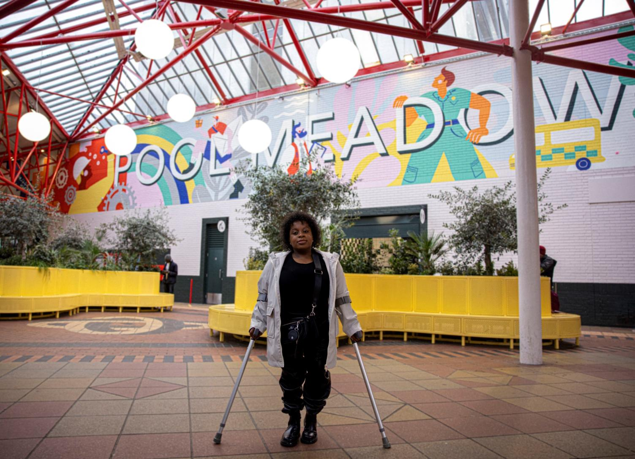

Image 1 - (c) ncat

### 4.1 Finding 1: Disabled people do not think transport is accessible. Most do not think this will change in the next 10 years

Our survey asked if each transport mode is accessible. The rating was on a scale of 0 to 10, where 0 is ‘not at all accessible’ and 10 is ‘extremely accessible’.

Most disabled people surveyed said that transport is currently not accessible in the UK. The average score for all modes of transport was 4.4 out of 10.

Cars and wheelchair accessible vehicles are the most accessible type of transport, scoring 7.2 out of 10. All other modes of transport were deemed mostly inaccessible, scoring 5 or lower.

Hire cycles and hire scooters were seen as the least accessible, averaging 2.1 out of 10. For detailed accessibility scores by mode, see **Figure 1: A bar chart showing average accessibility rating by mode of transport, on a scale of 0 to 10. 0 is ‘not at all accessible’ and 10 is ‘extremely accessible’**

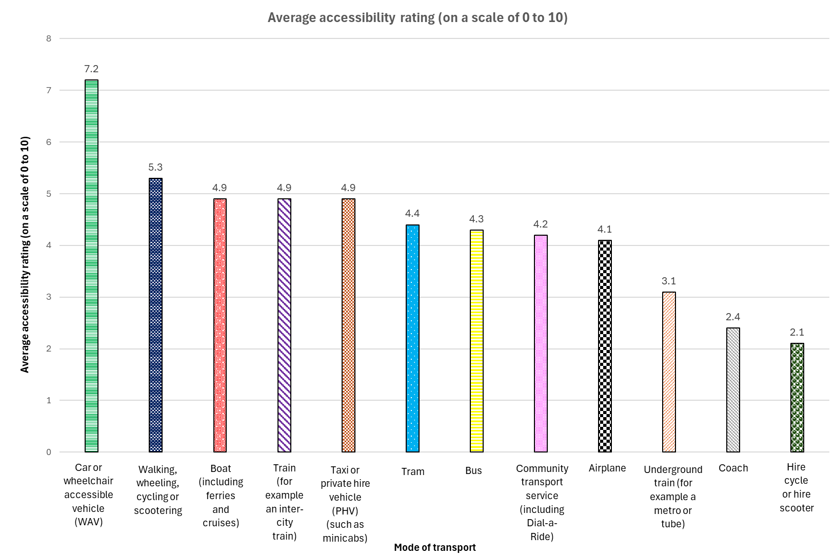

**Figure 1. A bar chart showing average accessibility rating by mode of transport, on a scale of 0 to 10. 0 is ‘not at all accessible’ and 10 is ‘extremely accessible’**

Most disabled people surveyed were not positive about transport accessibility improving in the future. When asked about how optimistic they are about change within the next 10 years, the average rating was 3.4 out of 10. The rating was on a scale of 0 to 10, where 0 is ‘not at all likely and 10 is ‘extremely likely’.

This varied by region, with people who live in London (4.1) or the East of England (4.1) being slightly more optimistic. Those living in the South West (3.1) and Scotland (3.1) and Wales (3.1) were less optimistic.

### 4.2 Finding 2: Most disabled people experience barriers when travelling. 92% face barrier(s) on at least one mode of transport

The survey asked disabled people about what modes of transport they use, and whether they face barriers while travelling.

Cars and wheelchair accessible vehicles were the most used mode of transport (951 respondents), followed by walking, wheeling, cycling or scootering (682 respondents).

92% of disabled people said they had experienced a barrier on at least one mode of transport. Train users face the most barriers, with 91% reporting at least one barrier. 90% of bus users face barriers, while 80% of both air travel and underground train users face issues. Full details by mode of transport are in **Table 1**.

#### Table 1. Percentage of disabled people reporting transport barriers, by mode of transport

| **Mode of transport** | **Number of disabled people who use this mode of transport** | **Percentage of disabled people who reported facing a barrier (%)** |
| --- | --- | --- |
| Train | 627 | 91% |
| Bus | 230 | 90% |
| Underground train | 307 | 86% |
| Aeroplane | 351 | 86% |
| Coach | 156 | 78% |
| Taxi or private hire vehicle | 667 | 77% |
| Walking, wheeling, cycling or scootering | 682 | 71% |
| Boat | 162 | 60% |
| Car or wheelchair accessible vehicle | 951 | 59% |
| Community transport service | 73 | 59% |
| Tram | 165 | 55% |
| Hire cycle or hire scooter | 46 | 50% |

## 5 How does inaccessible transport impact disabled people?

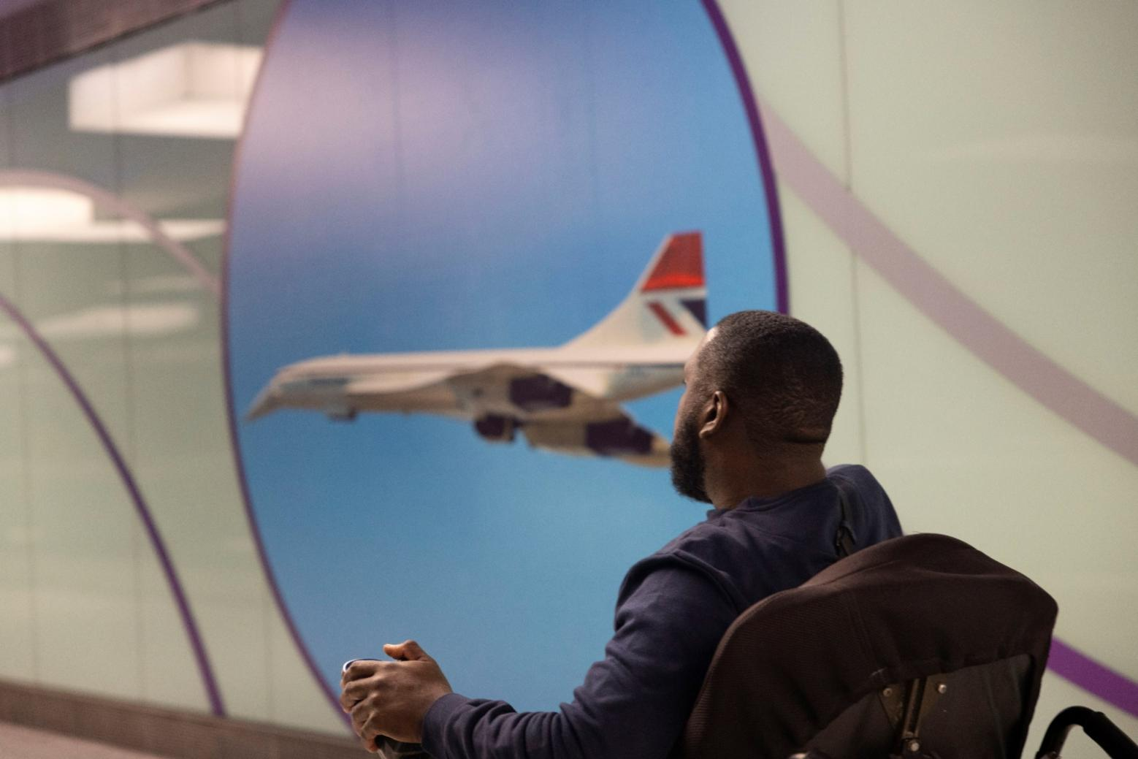

Image 2 - (c) ncat

### 5.1 Finding 3: Inaccessible transport makes disabled people travel less, and it makes journeys take longer

The survey helped us understand how often disabled people travel in the UK. This varied by mode of transport.

**How often do disabled people travel?**

Most disabled people surveyed, 66%, used cars or wheelchair accessible vehicles at least once a week. The second most common mode of transport was walking, wheeling, cycling or scootering. This is shown in **Figure 2**.

Most disabled people surveyed (90%) said they have used more than one transport mode over the past year. 10% had used just one mode of transport, and four people reported not travelling at all.

#### Figure 2. A bar chart showing percentage of disabled people using transport at least once a week, by mode of transport

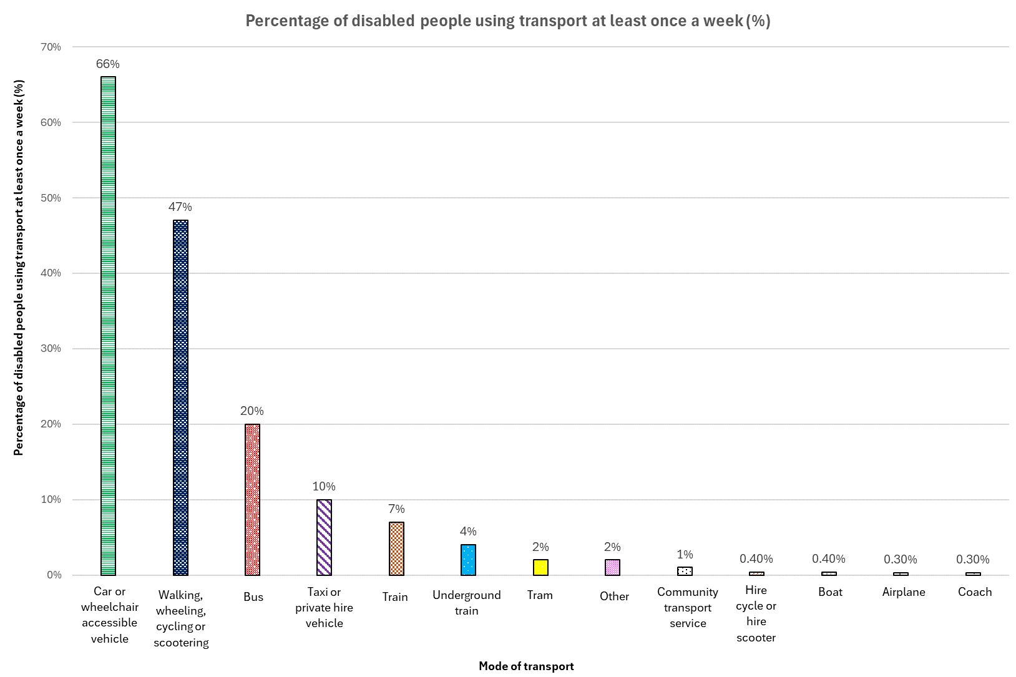

#### What is the impact of transport barriers on how disabled people use transport?

Transport barriers affect how disabled people travel. They create inequalities between disabled people and non-disabled people. Because of these transport barriers:

* 79% of disabled people **travel less** **often** because of the barriers they face. This is shown in **Figure 3.**
* 55% of disabled people **don’t make as many unfamiliar journeys**.
* 67% of disabled people **don’t make as many spontaneous journeys**.
* 84% of disabled people said that **travel** **takes more time** that it otherwise would have done.
* 70% of disabled people said that travel **costs them more money** than it otherwise would have done.

#### Figure 3*:* A pie chart showing the impact of barriers on travel frequency, by percentage of disabled people

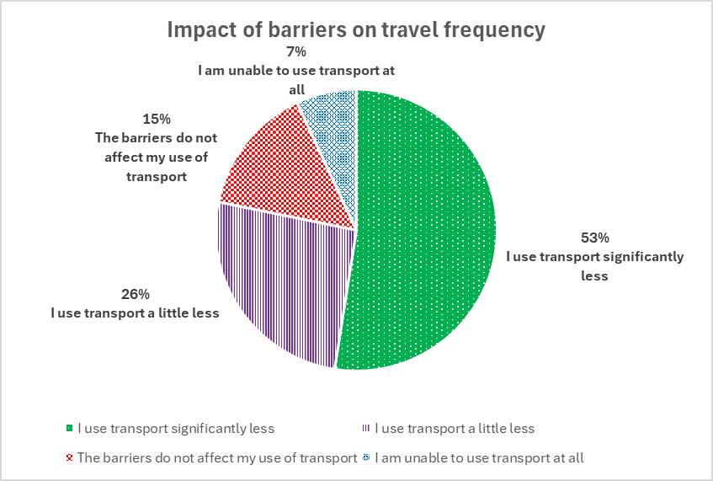

## 5.2 Finding 4: Inaccessible transport impacts the wellbeing of many disabled people

Disabled people were asked about how the barriers they face while travelling impact their physical and mental wellbeing.

### What is the impact of transport barriers on disabled people’s lives?

Transport barriers have a range of impacts on disabled people’s lives. Participants were asked to rate how transport barriers impact their wellbeing.

* 77% of disabled people said that transport barriers have a **negative effect on their physical or mental wellbeing**.
* 87% of disabled people said that it has a **negative effect on their independence and choices**.
* 60% of disabled people said that they **don’t feel confident** while travelling.

Participants were also able to select a range of ways in which inaccessible transport affects them. These are shown in **Table 2.**

### Table 2. Percentage of disabled people that are impacted by transport barriers, by type of impact

| **Impact of transport barriers** | **Percentage of disabled people (%)** |
| --- | --- |
| Stress while travelling | 75% |
| Increased pain and fatigue after travelling | 65% |
| Reduced confidence to go out and use transport | 57% |
| Takes longer to plan journeys and book tickets | 55% |
| Reduced confidence in transport staff | 49% |
| Increased social isolation | 45% |
| Risk or fear of accidents | 45% |
| Struggle to navigate the transport with ease | 41% |
| May miss important information or miss my stop | 27% |

In comments, disabled people said that transport barriers affect them in other ways. These include:

* **Fear of travelling itself, and its impact on their health**. As one disabled person said, “Fear of infection”. Another commented that they had experienced “Autistic burnout or shut down after travelling that can last for several days.”
* **Reliance on a single mode of transport**. As one disabled person noted, “[I] tried to go out without a car for a year. It made me ill and isolated. Now [I] use a car again!”.

## 6 What barriers do disabled people face while travelling?

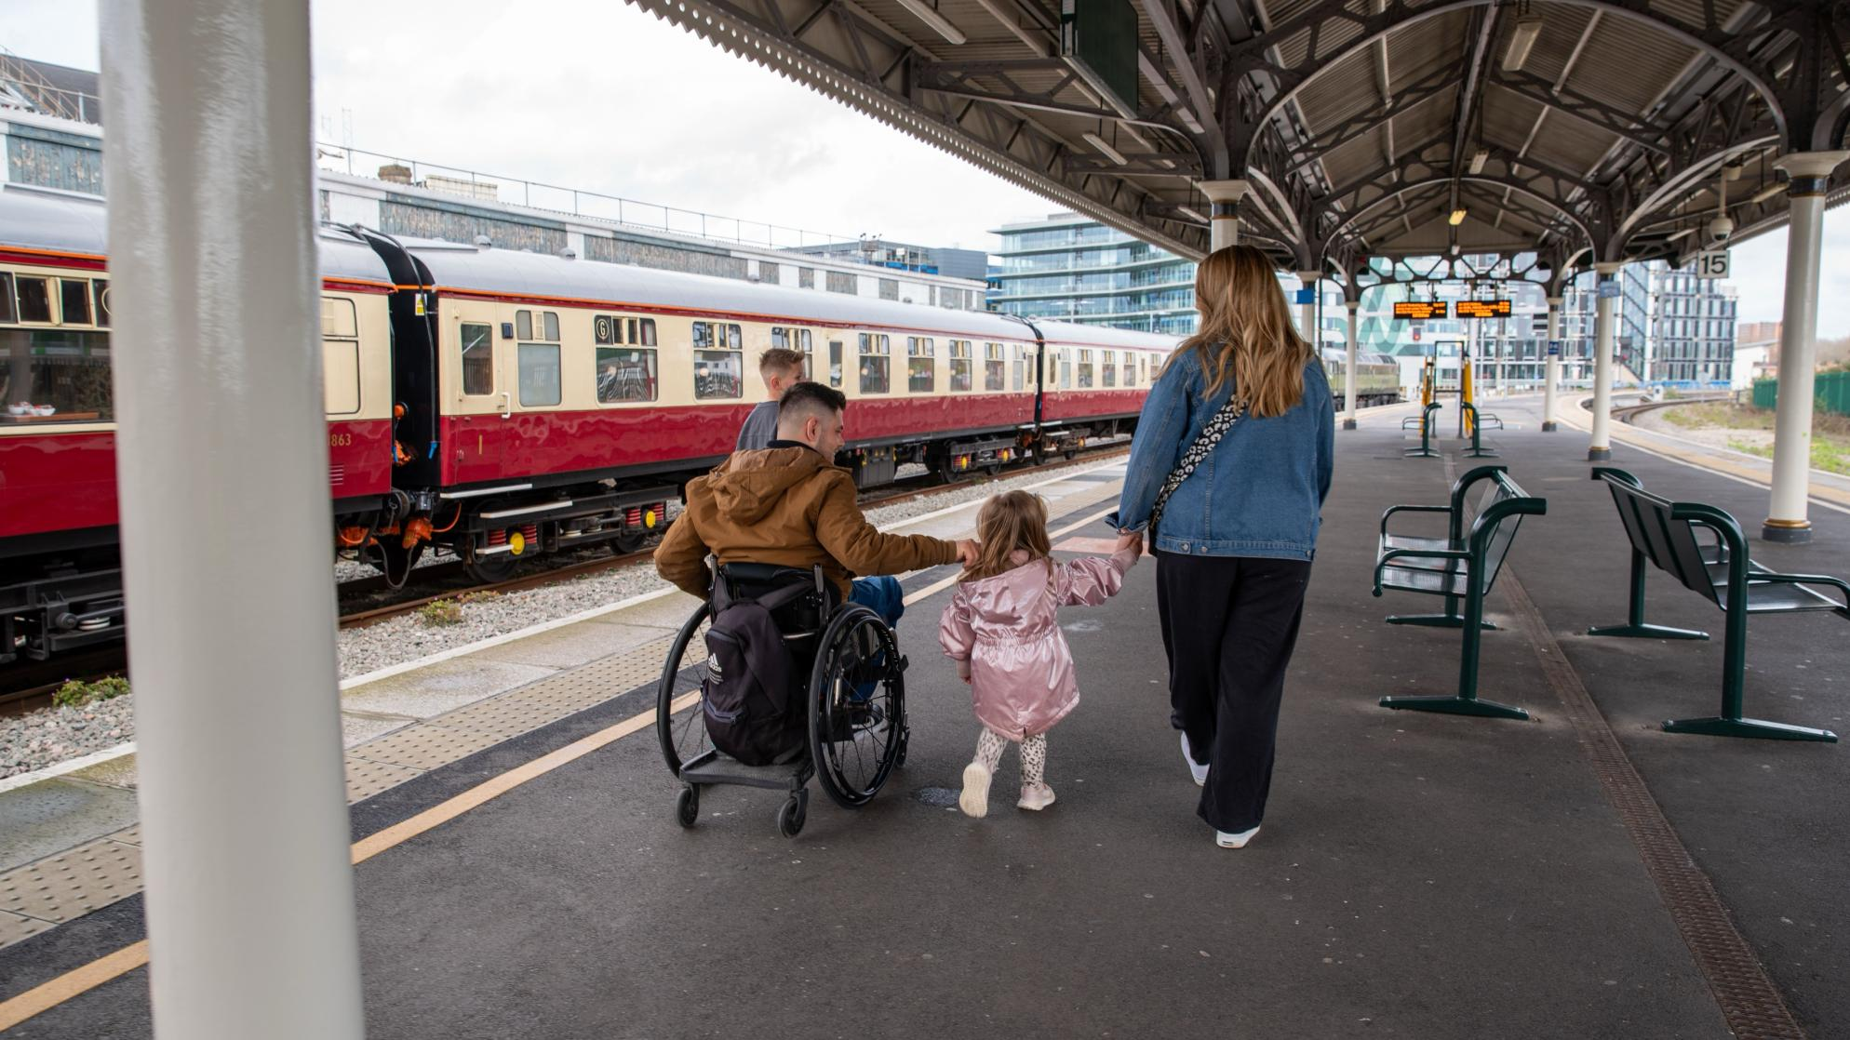

Image 3 - (c) ncat

### 6.1 Finding 5: Disabled people face many barriers when they travel. These include badly designed and cluttered streets, unreliable step-free access, and poor staff assistance

Participants were asked about the barriers they experience when travelling in the UK. The feedback highlighted that the issues with accessible transport are diverse and widespread.

Participants were asked to select the barriers they experience for each mode of transport that they use. The barriers that impact the highest proportion of disabled people are listed below. They are also shown in **Table 3.**

* **Pavement and curbs** are poorly designed.
* **Getting on and off a vehicle**, is difficult, including step free access, gaps, ramps and lifts.
* **Things on the street** get in the way, such as advertising signs and parked cars.
* **Using staff assistance** is an issue, including people not being around to help
* **Step-free stations** are lacking or unreliable.

#### Table 3. Percentage of disabled people impacted by type of transport barrier, by mode of transport

|  |  |  |
| --- | --- | --- |
| **Transport barrier** | **Mode of transport** | **Percentage of disabled people with this barrier (%)** |
| Pavement and curbs | Walking, wheeling, cycling or scootering | 65% |
| Step-free access on/off vehicle | Train | 64% |
| Things on the street | Walking, wheeling, cycling or scootering | 59% |
| Step-free access on/off vehicle | Underground train | 58% |
| Entering a taxi | Taxi and PHV | 56% |
| Using staff assistance | Aeroplane | 53% |
| Step-free stations | Train | 52% |
| Using staff assistance | Train | 50% |
| Step-free access on/off vehicle | Coach | 48% |

The barriers that people face vary depending on the mode of transport they are using. The top three barriers for each mode of transport are shown in **Table 4**.

#### Table 4. Percentage of disabled people facing barriers, by type of barrier and mode of transport

| **Mode of transport** | **Percentage of disabled people (%) by the most frequently cited barriers faced** |
| --- | --- |
| Aeroplane | Using staff assistance – 53%  Moving within vehicle – 46%  Toilets and changing places on vehicle – 46% |
| Boat | Step-free access on/off vehicle – 35%  Moving within vehicle – 25%  Toilets and changing places on a vehicle – 23% |
| Bus | Space constraints - 49%  General station design – 44%  Step-free access on/off vehicle - 44% |
| Car or wheelchair accessible vehicle | Car parking – 37%  Toilets and changing places at stops – 34%  Pavement and curbs on the street, stop or parking place – 30% |
| Coach | Step-free access on/off vehicle – 48%  Seating on vehicle – 24%  General station design – 23%  Planning a journey – 23% |
| Community transport service | Booking and payments – 34%  Step-free access on/off vehicle – 15%  Planning a journey – 14% |
| Taxi or private hire vehicle | Entering a taxi – 56%  Pavement and curbs on the street, stop or parking place – 29%  Step-free access on/off vehicle – 28% |
| Train | Step-free access on/off vehicle – 64%  Step-free stations – 52%  Using staff assistance – 50% |
| Tram | Step-free stations – 24%  Public and staff attitudes and behaviours – 22%  Space constraints – 22% |
| Underground train | Step-free access on/off vehicle – 58%  Step-free stations – 52%  General station design – 37% |
| Walking, wheeling, cycling or scootering | Pavement and curbs on the street, stop or parking place – 65%  Things on the street – 59%  Public and staff attitudes and behaviours – 36% |

Note that hire bike results have been removed from this table due to the low number of participants.

### 6.2 Finding 6: Inaccessible streets and pavements are the biggest barrier in public spaces

#### What did our survey find?

Disabled people experience barriers getting around, because of things on the street and poorly designed pavements.

* **Things on the street get in the way.** This includes things like advertising signs, bins and cars. They impact **59%** of people that walk, wheel, cycle or scoot.
* **Pavement and curbs are poorly designed.** They affect **39%** of people on streets, at transport stops and parking areas. This question was asked to those who walk, wheel, cycle, or use buses, cars, community transport services, private hire vehicles, taxis and wheelchair accessible vehicles.
* **Pavements and curbs are less of a problem at stations**. There, **18%** of users of aeroplanes, boats, trams, trains and underground trains face barriers.
* **Benches and resting places are lacking.** This impacts **24%** of people who walk, wheel, cycle or scoot.

#### Who does this barrier affect?

**Things on the street get in the way:**

* Impacts disabled people in London more than people living in other areas. This is a barrier for 73% of London residents who walk, wheel, cycle or scoot. It impacts those in Wales the least (31% of respondents).
* Impacts 89% of wheelchair users, 89% of those that need support from another person, and 94% of those that use an assistance dog.

**Pavements and curbs are poorly designed** (at streets, stops and parking places):

* Impacts people that walk, wheel, cycle or scoot (65%) more than those that use other modes of transport. It affects 44% of bus users, 30% of car or WAV users, 29% of taxi or private hire vehicle users, 22% of coach users, and 5% of community transport users.
* Impacts many disabled people across the UK. However, in Wales (29%) and Yorkshire and the Humber (31%), people are affected less than in other regions (39%).

**Benches and resting places are lacking:**

* Impacts 24% of people that walk, wheel, cycle or scoot.
* Impacts disabled people living in the South West more than those living in other regions. Here, it impacts 30% of respondents compared to the national average of 24%. It impacts those living in the East Midlands the least (16%).

#### What did people say?

* **Cars and vehicles take up space on the pavement**. One disabled person said they have an issue with, “Vehicles parked on pavements blocking access. I have been stuck unable to go anywhere for long periods of time because of this, MULTIPLE times. Sometimes I have to cancel the whole journey because there is no other route.”
* **Bins, advertising signage, and trees / bushes block the pavement**. In a respondent’s words, “I have experienced ongoing problems with shopkeepers placing their signs on the footpath, just giving enough space for pram users and pedestrians just enough space to get past, but not enough for mobility scooter, and then stand laughing.”
* **The surface of pavements is uneven, and people are uncertain about whether dropped kerbs will be available**. As a disabled person noted, “Bad condition of pavements, lack of dropped kerbs, roadworks hampering access i.e. blocking dropped kerb.”
* **There isn’t enough suitable seating**. Several people commented on the need for more comfortable waiting spaces when travelling. As one aeroplane user comments, there is an “Inadequate seating provision at the gates.” Similarly, a bus user noted that some bus shelters are being replaced with “totally useless high up 45 degree slippery plastic ledges, which mean all your weight is still on your feet. They are very high and completely unsuitable for mobility impaired.”

|  |
| --- |
| **Personal stories: Travel diaries**  Maggie[4] is a woman in her seventies who went on a holiday in Wales with her family. She went to a village where paths and walkways were often narrow and uneven. She has mobility and dexterity impairments and uses a mobility scooter while out. She experienced barriers with the built environment in a rural area.  When she told us about her journey, she said she “Took my mobility scooter around the village with my sister-in-law, her husband and my husband, to look around, as we were all on holiday, staying in a caravan and it is a very old scenic village.  My main problems were lack of pavements and/or lack of wide enough pavements and/or lack of dropped kerbs, or the dropped kerbs were too high which meant that for most of the time I had to drive my scooter on the road. This was dangerous because of the cars, and made my sister anxious, but it did mean I could travel alongside my sister and talk to her. When able to get on the pavement I had to go in front of her as the pavements weren't wide enough, so we couldn't talk to each other.  The best part was the side roads as there were no pavements, less traffic and the cars were driving more slowly.”  The impact of this uneven and inaccessible streetscape was “Discomfort, danger and lack of control of my scooter.”  Maggie felt that this presented a risk to her and that there were improvements that could improve her journey. These included, “Better pavements, wider and with dropped kerbs that actually are dropped. Alternatively, lanes in the road like cycle lanes, but for mobility scooters.” |

### 6.3 Finding 7: Getting on and off vehicles is a concern for many disabled people

#### What did our survey find?

Disabled people said that step-free access and level access is a barrier when travelling.

* **Step-free access on and off a vehicle is lacking**.This includes gaps on to vehicles, ramps and lifts. This is a barrier for **44%** of respondents. This question was asked to users of boats, buses, coaches, community transport services, taxis or private hire vehicles (such as a minicab), trains, trams, and underground trains.
* **Getting in and out of a car or taxi is difficult.** This creates challenges for many disabled people. Entering a taxi was a barrier for **56%** of taxi and private hire vehicle users. Although the survey didn't specifically ask about getting into cars or wheelchair accessible vehicles, many people mentioned these issues in their comments. People also highlighted problems with loading and unloading mobility aids.

#### Who does this barrier affect?

#### Step-free access on and off a vehicle is lacking:

* Impacts users of trains (64%) and underground trains (58%) most. The most accessible public transport modes in terms of step-free access are community transport (impacting 15% of users), and tram services (impacting 18% of users).
* Impacts respondents in London (50%), the South East (48%) and East of England (48%) more than people in other regions. People living in the South West (39%) and Northern Ireland (38%) are impacted the least.
* Impacts 73% of wheelchair users that use boats, buses, coaches, community transport services, taxis or PHVs, trains, trams, and underground trains.

**Getting in and out of a taxi is difficult:**

* Impacts respondents in the East Midlands more (68%) than the national average (56%). Residents in Northern Ireland (33%), the South West (47%) and Wales (48%) are affected the least.

#### What did people say?

* **The physical gap / height difference between trains and platforms is an issue**. As one disabled person commented, “Many of the ‘step free’ platforms still have huge gaps or a small step up to the trains which can cause a lot of anxiety and not all wheelchairs can manage.”
* **Getting in and out of a car is a barrier**. Several people commented in that they have “issues getting in and out of the car” or “issues with the height of car entry”.
* **Getting mobility aids into vehicles** is also a barrier for many disabled people. Comments included: “[I] can’t lift [my] mobility scooter into [the] car independently, so [I] have to have someone with me” and “time and effort to get wheelchair and luggage in and out”

|  |
| --- |
| **Personal stories: Travel diaries**  Stella is a woman in her thirties who lives in Scotland. She has a variety of impairments and health conditions and a range of different access needs. She uses a powered wheelchair.  She told us about an incident she had whilst on a trip to the hairdressers. She had booked a haircut which, due to an earlier allergic reaction, she could no longer drive to. “I had to call taxi operator and outline I had a power wheelchair and required a fully wheelchair accessible vehicle. I waited roughly 20 minutes for a taxi to arrive.”  It was on the return journey from her haircut that further barriers began to emerge. “On my way home, I waited over an hour for a taxi to turn up….They sent a small electric hatchback, and the driver couldn’t contact the taxi company to get someone to pick up my fare. £24 it cost in taxi, I wouldn’t have been safe on a bus and I have no bus stops close by.”  She reflected that these barriers impacted her day. “A nice experience usually my self-care trip. Costs so much more. The stress it caused waiting for a taxi, my family members began to panic when I did not arrive home 30 minutes after my appointment”.  To improve her experience next time, she asked that there be “More available taxis priority for people in wheelchairs.” |

### 6.4 Finding 8: Transport stations are not designed to meet the needs of disabled people

#### What did our survey find?

Disabled people told us that the design of transport stations creates issues for them when travelling.

* **Toilets and changing places at stations and transport stops are unavailable or poor quality. 33%** of users of boats, cars, trains, trams, and underground trains face barriers.
* **Step-free access at stations is lacking or unreliable**. This includes things like stairs to train platforms and lifts. This is a barrier for **43%** of users of aeroplanes, boats, trains, trams, and underground trains.
* **Stations are poorly designed.** Thisincludes barriers such as confusing signs or inaccessible buildings. This impacts **27%** of users of aeroplanes, boats, buses, cars and WAVs, coaches, trains and underground trains.

#### Who does this barrier affect?

**Toilets and changing places at stations and transport stops are unavailable or poor quality:**

* Impacts train users most (37% of users of trains) and tram users least (15% of users).
* Impacts more disabled people in the West Midlands than those in other areas. In the West Midlands, this barrier affects 42% of users of boats, cars, trains, trams and underground trains.

**Step-free access at stations is lacking or unreliable:**

* Impacts those using trains and underground trains (52% of users) most. The most accessible stations are those for boats (impacting 20% of users) and tram (impacting 24% of users).
* Impacts those living in North East (51% of respondents) and Northern Ireland (50%) more than those in other regions. It impacts those living in the South West the least (32%).

**Stations are poorly designed:**

* Impacts bus users (44% of users) and underground train users (37% of users) more than other modes of transport.
* Impacts disabled people across the UK. However, it impacts those in London (35% of respondents) slightly more than others. It affects those in Wales the least (22%).

#### What did people say?

* **Stations are entirely inaccessible for some people.** Many respondents selected ‘general station design’ as a barrier and told us that stations themselves were inaccessible. One respondent said that they, “can’t enter [the] station at all.”
* **Toilets and changing places can be unavailable**. One disabled person noted, “Being blind I use the disabled toilets. These are often out of order and not clean (in Britain particularly unfortunately).”
* **Lift availability and the volume of stairs impacts people at stations**. As a disabled person said, “Sometimes there is no lift at all or a very long wait, as everyone uses it out of convenience.”
* **Walking distances at transport stations can be too long**. As one underground train user noted, “Extended walking between different lines e.g. particular problems at Victoria where passengers are routed [through] long walks in tunnels as part of their passenger management system.”

|  |
| --- |
| **Personal stories: Travel diaries**  Annabel is a woman who lives with a range of impairments, including a mobility impairment and chronic pain, which means she often can’t stand for long periods. She told us about picking her brother up from the train station.  She said, “I drove to the train station to pick up my brother…. I arrived at the train station car park 10 minutes before his train arrived. I couldn't find the accessible parking because it was on the second floor rather than the ground floor which was unusual. When I eventually found them, all but one spot (the furthest away) was full. There were 6 cars with no blue badges displayed - I had to walk past them all to get to the station entrance...”  This misuse of the accessible parking bays meant that even before she had got into the station, Annabel had expended energy in overcoming a barrier created by the behaviour of others. She then went on to say, “When I finally got into the train station…there was nowhere to sit within the arrival hall (as in no seating provided at all), and the only seating was within the food area which was limited fixed benches facing away from the arrival gates. This meant I could sit down but not see people arriving to look out for my brother and he couldn't see me. I sat here for 15 mins then sat on the floor of the arrival hall as it got closer to his arrival time. This wasn't comfortable.”  This experience was unpleasant for Annabel, and she reflected that “I was in extra pain and discomfort that could've been avoided.”  To improve her experience next time, she recommended that the station implements “Seating within arrivals, additional seating in general,” and “parking attendants checking accessible spaces were not being abused.” |

### 6.5 Finding 9: Interactions with other people can make travelling difficult

#### What did our survey find?

Disabled people said that they face barriers when travelling because of how the public and staff think and behave.

* **Staff assistance is unreliable**.This includes staff being unavailable, even if assistance is booked. **47%** of aeroplane, train, and underground train users highlighted this issue.

Many responses noted that taxi drivers often don’t know how to assist disabled passengers, leading to uncomfortable situations. Additionally, some disabled people highlighted communication challenges with drivers for buses and coaches.

* **Public and staff attitudes and behaviours can be negative.** Thisincludesthe way that staff and the public interact with and treat disabled people when travelling. This impacts **31%** of respondents. This question was asked to those who use any mode of transport.
* **Seeking staff assistance can be hard.** This barrier includes booking passenger assistance at a station. This impacts **24%** of users of aeroplanes, boats, trains, trams and underground trains.

#### Who does this barrier affect?

**Staff assistance is unreliable:**

* Impacts those that use aeroplanes (53% of users) and trains (50% of users) more than those that use underground trains (36% of users).
* Impacts those living in Scotland the most (53%) and the South West slightly the least (41% of respondents).
* Impacts people that use an assistance dog most (80% of respondents).

**Public and staff attitudes and behaviours are negative:**

* Impacts aeroplane and bus users most (44% of users for both). 36% of those that walk, wheel or cycle, and 35% of train users face this barrier. Community transport users are the least affected, at just 7%, perhaps due to the dedicated nature of these services.
* Impacts those with mental ill health, social or behavioural, learning or communication impairments more than others. For example, 55% of those with mental ill health stated they face barriers from public and staff attitudes.

**Seeking staff assistance is hard**:

* Impacts aeroplane users most (30%) and taxi or private hire vehicle users least (11%).
* Impacts people in Scotland (36% of respondents) slightly more than other regions. This barrier impacts residents in the North West the least (18%).

#### What did people say?

* **Staff assistance is unreliable**. Transport staff can be difficult to find. As one person said, “No staff means no help!”.

Transport staff do not consistently assist disabled people, even when assistance is booked. In a disabled person’s words, “I have been LEFT on the train at an end station before now, I have also had to stick my footrest in between the closing doors as no one has come to meet me with a ramp.”

Another person said, “[The] bus driver doesn't want to get up to deploy the ramp. [They] will do it but makes me feel like a burden and awkward.”

* **Services being inaccessible means that people need to rely on staff assistance**. As a disabled person noted, “Budget airlines don't pay for air bridges so disabled people have to rely on assistance or climb often steep stairs, get in and out of inaccessible buses (drivers are not trained well and NEVER lower the bus, even if it has that capability).”
* **Transport staff and members of the public do not make space for disabled people**. This includes, “drivers not making people fold prams to make room, so leaving me to wait for the next bus.” In a disabled persons words: “people [are] unwilling to fold up baby buggies so I can access the wheelchair space.”
* **Verbal and physical abuse is a concern for many**. One respondent described it as “abuse from others, following, stalking me, yelling at me shouting things like you’re not really disabled.”

An experience by one disabled person is, “Once while boarding a bus, wearing my sunflower lanyard and using my walking stick, a bus driver trapped me in the doors as I was getting on. When I screamed, he opened the doors again and laughed. He laughed at me before apologising. Trapping me in the door dislocated my shoulder.”

* **Transport staff not having the right training**, for example “The safety aspect of travelling in a hired cab is deplorable with nine out of ten drivers not understanding that the seatbelt laws apply to wheelchair users as well. They have no knowledge of how to lock down a passenger travelling in their wheelchair. They have the meter running whilst they are loading you including getting the ramp out and also if they are clamping you in.”

|  |
| --- |
| **Personal stories: Travel diaries**  Liam is a man in his 50s who uses a walking stick. As well as having a mobility impairment, he is also neurodivergent and has mental health conditions. He told us about the negative staff interactions he experienced when getting a train.  “At [the train station] l I met my friend and we then 'checked in' at the station office. The door was shut and the member of [staff] sighed and slammed their pen down on their desk.  I gave my name and said I had booked assistance (using the excellent [Passenger Assistance] app).  We were told to 'take a seat'. Because I have mobility issues, I cannot stand but there were no free seats so we sat on a kids seat.  The train ran 20 minutes but none of the [train operator] staff kept us abreast of what was going on. A member of staff asked my name and then disappeared.  When I booked the assistance I asked for 'ramp for boarding' [and] help finding a seat. None of this happened and we had to ask the staff member to get the ramp.  The platform was heaving and the train was heaving too. The staff member did not help find a seat and we had to ask [another passenger] to find a seat.  We were unsure of assistance at [the alighting station] but this was given to us and a ramp and a buggy was provided.  [The train operator] was really bad at [the departure station] and offered an unacceptable level of service on their trains on pre-booked assistance.  Staff attitudes stank and there was a lack of empathy.”  As a result of the failed assistance, Liam said, “it started me off feeling highly anxious”.  What would have made the journey better? “If the [train operator] team at [the departure station] followed the assist request without having to ask or feel like you're troubling them. [And] a separate seating area for passengers with additional needs at [the departure station].” |

### 6.6 Finding 10: The design of public transport vehicles makes it hard for disabled people to be comfortable when travelling

#### What did our survey find?

Disabled people said that moving within a vehicle and space constraints were the biggest barriers related to vehicle design.

* **Moving vehicles create problems for people on board**, including things like lack of handrails or vehicles not stopping for long enough. This was reported as a barrier by **33%** of respondents. This question was asked to people who use aeroplanes, boats, buses, coaches, trains, trams and underground trains.
* **Seating on vehicles is unavailable or unsuitable**. This includes not being able to find a seat on the vehicle or the seat itself causing pain, impacts **27%** of respondents. This question was asked to those who travel on aeroplane, boat, bus, coach, train, tram, and underground train.
* **Wheelchair spaces aren’t always available**, for example when luggage is stored there. This impacts **29%** of boat, bus, coach, train, tram and underground train users.
* **Toilets and changing places on vehicles are poor.** Thisimpacts **39%** of respondents. This question was asked to those who use aeroplanes and boats. We acknowledge that lack of accessible toilets on other modes, such as trains is also a barrier, however it was not included in the survey.

#### Who does this barrier affect?

**Moving vehicles create problems:**

* Impacts aeroplane users (46% of users) and bus users (42%) most. Impacts tram users least (19%).
* Impacts people living in North East more than other regions (45% of respondents).

**Seating on vehicles is unavailable or unsuitable:**

* Impacts aeroplane users the most (38%) and boat users least (18%).
* Impacts people living in North East (39% of respondents) more than other regions. Impacts people living in the East of England (22%) the least.

**Wheelchair spaces aren’t always available:**

* Impacts bus users (38% of users) and underground train users (33%) more than other modes of transport. Impacts coach users least (15% of users).
* Impacts residents in West Midlands more than those living in other regions (38%).

**Toilets and changing places on vehicles are poor:**

* Impacts those using aeroplanes (46% of users) and boats (23% of users).
* Impacts people living in Scotland (54% of respondents) more than those in other areas. It impacts people living in London the least (27% of respondents).
* Impacts 66% those who use a wheelchair, which is higher than the national average.

#### What did people say?

* **Moving while a vehicle is travelling is difficult**. One person commented, “Walking to the toilet onboard when coach is moving is scary and dangerous; I’m so shaken by the movement on the road I’m scared I’ll fall down.”
* There are often not enough seats and limited personal space on vehicles. One respondent described it as, “Not enough chair spaces. Always get bags or body parts in my face.”
* **Vehicles move when people are boarding and alighting**. A disabled person noted, “Getting to the doors in time when the train is crowded, I can't get wheelchair past people in time.”
* **There are insufficient wheelchair spaces on vehicles**, and they are sometimes used for other reasons, such as to store suitcases. One disabled person commented, “If there is already a wheelchair user on the bus have to wait for the next one which in my area can be another 30 - 60 minutes.”.
* Another said, “Not enough wheelchair spaces on trains and when there is one it is also a luggage space. These should be separate. People (including staff) ask if you don’t mind having other people’s luggage around you because it is a luggage space when a wheelchair isn’t in it and they get annoyed when you say no.”

### 6.7 Finding 11: Car journeys have specific challenges, including finding suitable parking spaces

#### What did our survey find?

Although cars were noted by respondents as the most accessible mode of transport, there are still barriers related to cars and wheelchair accessible vehicles (WAVs).

* **Suitable parking spaces aren’t always available**. This impacts **32%** of car and wheelchair accessible vehicle users.
* **Refuelling a vehicle can be difficult**. Barriers related to refuelling a petrol or electric car impacts **19%** of car and wheelchair accessible vehicle users.
* In comments, many disabled people highlighted that another barrier they face is **dependence on drivers** to use cars or WAVs.

#### Who does this barrier affect?

#### Suitable parking spaces aren’t always available:

* Impacts people living in the West Midlands and East Midlands more than the rest of the country (39% of respondents for each). Wales, with 21% of respondents affected, and Yorkshire and the Humber, with 22%, experience this barrier the least.

**Refuelling a vehicle can be difficult:**

* Impacts people living in the East Midlands (28% of respondents) more than the rest of the country. Those living in the North East are impacted the least (9%).

#### What did people tell us?

* **It’s difficult to find suitable places to park**. As one person outlined, “Lack of disabled parking in town centres”.
* **Parking spaces don’t have enough space**. One disabled person commented, “If I am using my car boot mobility scooter, I need a space wide enough to get it out of the car and assemble it. Not being able to find suitable parking affects the time I might leave the house, and I have returned home when I have not been able to find suitable parking.”
* **Dependence on others to be able to use cars**. One disabled person explained “[I] need to be accompanied by carer or family as I am unable to gain access to wheelchair ramp and restraints and secure or release wheelchair with current WAV vehicle. I have a new WAV on order with the technology for me to drive and have independence to go out alone [without] having to depend on others”

|  |
| --- |
| **Personal stories: Travel diaries**  Clare is a 43-year-old woman living in Wales. She has a mobility impairment and uses a walking stick. Here, she shares her experience of taking her child to the theatre and the ways that access barriers impacted her enjoyment of the trip.  After driving to the venue, she experienced significant issues with parking her vehicle. She told us the “Car park was very busy, [with] limited disabled bays. I couldn't park in any disabled bays so hurt myself getting out of [the] car.”  This experience led to her not feeling safe and not feeling very independent. Despite hurting herself, she was still able to enjoy the pantomime but rated the experience overall as “Somewhat negative”.  She told us that the simple change of having “More disabled parking spaces” would have improved her experience and prevented this injury. |

### 6.8 Finding 12: Accessing information before and during a journey can be difficult

#### What did our survey find?

Disabled people experience barriers related to accessing information before and during their journey.

* **Finding and flagging down vehicles is difficult.** This includes things like seeing a bus number to get it to stop. This was reported by **24%** of bus and coach users. In comments, people said that bus timetables aren’t reliable, and buses don’t always turn up. Although the survey didn't specifically ask about getting into taxis, many also mentioned this issue in comments.
* **Information on vehicles is unavailable or inaccessible.** This includes the station or stop name not being displayed on a screen or read out loud. This was a barrier for **23%** of respondents. This question was asked to those who use boats, buses, coaches, community transport services, hire cycles, taxis or PHVs, trams, trains and underground trains.
* **Audio and visual information at stations could be improved.** This includes audio announcements being quiet, poor signage and last-minute changes to train platforms. This barrier was reported by **16%** of aeroplane and boat users. Many comments also highlighted that this is an issue for trains.
* **Accessibility information is limited when planning a journey.** This was a barrier for **21%** of those asked. This question was asked for all transport modes.

#### Who does this barrier affect?

**Finding and flagging down vehicles is difficult:**

* Impacts bus users (27% of users) and coach users (11% of users).
* Impacts people in London slightly more than other regions, with 33% of respondents reporting this barrier. It impacts people in the East Midlands (15% of respondents) and Scotland the least (17%).

**Information on vehicles is unavailable or inaccessible:**

* Impacts bus users (34% of users) and train users (30%) more than other modes of transport.
* Impacts people living in London (30% of respondents) and the West Midlands (29%) the most.

**Audio and visual information at stations could be improved:**

* Impacts 17% of those use aeroplanes and 12% of those that use boats.
* Impacts people that live in the East Midlands slightly less. 9% of respondents report this barrier, compared to the national average of 16%.

**Accessibility information is limited when planning a journey:**

* Impacts those that use aeroplane (30% of users) most and taxi or private hire vehicle least (12% of users).
* Impacts people living in London (33% of respondents) slightly more than other regions. It impacts respondents in the East Midlands (23%) and Wales (22%) slightly less.

#### What did people say?

* **Identifying transport stations, stops and vehicles is difficult.** One disabled person described it as, “Finding the bus stop and how do I know my bus is approaching. How do I know which one is my bus?” Another stated, “Finding the taxi, especially when they are on an app.”
* **There is not clear enough navigation information, such as when to get off a vehicle**. The need for more information was highlighted by some respondents, including, “Knowing I am on the correct train line, going to the correct destination, navigating the tunnels to get to the correct line.”

Some wheelchair users commented that the position of the wheelchair space on buses makes it difficult to access navigational information. One disabled person said, “It’s impossible to see the stop display board from the wheelchair space [and] audio announcements are often switched off or too quiet.”

* **The audio quality of announcements can be poor**. It was noted that it can be difficult to hear and interpret audio announcements, particularly in noisy environments. One disabled person said, “Not understanding announcements as they sound garbled.”
* **There isn’t a lot of accessibility information when planning a journey**. Several disabled people provided comments about the need for better information when planning a journey. This includes information about suitable parking spaces, toilets, roadworks, and step-free routes. People also said that they did not know if they would be able to access the vehicle (such as a coach or taxi) when it arrives. One respondent said, “Not knowing if there will be accessible parking, toilets, etc at the destination or at stops on the way.”
* **It’s not always possible to plan a journey in an accessible way**. People experience barriers when using journey planning tools, or pre-booking services. For example, not all pre-bookable services can be booked by phone. A community transport user commented, “I struggle with phone calls, so it’s difficult to book.” In addition, a bus user noted, “I find most bus timetables difficult to understand.”

|  |
| --- |
| **Personal stories: Travel diaries**  Talia is a young woman who commutes to work through London. She is Deaf, a BSL user, and also manages nonvisible health conditions.  On this journey to work, getting to the office took an extra hour due to the barriers she experienced. “There was an issue with the [train] line, but no information came up on any of the screens to explain this (I rely on information in text format). The information displayed only said that there was a delay at the other end of the line, which should not affect this particular area.  I was waiting for ages on the platform. I could see people a few people walking away, but I continued to wait. My hearing aid was malfunctioning, so I spent some time fiddling around trying to sort it. When I finally was able to turn it on again, I realised there were announcements being made. But I couldn't follow any of it. I tried to ask a fellow passenger but didn't understand what he said in response.  Then I finally saw a member of staff and walked down to speak to them. I told them I was deaf and asked them to explain to me what was going on. I was told that there was an issue and that they did not know when the issue would be resolved. The member of staff (who I decided to stand near) continued making more announcements but I couldn't lipread him as he had the microphone to his mouth. I tried to ask him for information afterwards, but he was distracted and did not look at my face properly. I gave up and decided to take the alternative route to work.”  As a result, Talia said, “I found this whole experience very stressful. It also affected my ability to manage my health needs on that day (I usually need to arrive at work 15-20min early in order to do this), which added to the stress of the day.  [I] was really disappointed that the info updates on the screen did not reflect the most up to date information, in line with the [audible] announcements made. It meant that I could not make the most informed decisions as to how to proceed with my journey, as other passengers did. I don't understand why, because the technology is certainly available to create a more accessible experience.” |

### 6.9 Finding 13: Loud and bright transport stations and vehicles can be overwhelming

#### What did our survey find?

**Sensory elements can be overwhelming.** This includes stations being too loud, noisy, or too bright. This is a barrier for **14%** of respondents. This question was asked for aeroplane, boat, train, tram and underground users.

#### Who does this barrier affect?

**Sensory elements can be overwhelming:**

* Impacts those that use aeroplanes, trains and underground train users more (16% of users) than tram users (6%) and boat users (7%).
* Impacts people with communication (36%), learning (36%), mental ill health (39%) and social or behavioural (41%) impairments more than those without these impairments.

#### What did people say?

* **Crowding, lights and noises at transport stations and on vehicles can be overwhelming.** Some disabled people commented on the sensory overload of travelling. One person commented that they experience, “Difficulties on platform with anxiety and overwhelm.” Another noted, “[I] can get sensory overload from noises, lights, mass of people moving etc.”

|  |
| --- |
| **Personal stories: Travel diaries**  Kate is a woman who travels using a variety of different transport modes. She lives and works in London and has extensive experience navigating the public transport system. She is neurodivergent and lives with anxiety, communication difficulties and non-visible health conditions, which can make travelling more difficult and stressful. Here, she tells us about a typical journey commuting home from work.  She explained that she “headed to the nearest bus stop…which was shut so then I walked on more to [the] next bus stop in the dark and cold.  Got onto the bus and it was very busy, standing room only, and I felt in the way. I travel with a wheelie case for my laptop that can get in the way when it's busy. Got to [underground] station as [it] was too late to get an overground (preferred route) and then got a tube… then another tube…and then walked home... Got confused when getting tubes [underground trains] during the change between tubes as had to take some stairs.”  About the journey overall, she told us, “It was okay, just takes a while in rush hour and can be stressful. The route to my workplace is long as it’s in the middle of nowhere and not near a train station.”  She explained that due to her sensory needs, “Avoiding rush hour is better for me, I get overwhelmed by rush hour.”  In another travel diary, Kate compares this journey to a positive one on the London Overground, where the trains were ‘warm, clean, had free seats and quiet’. |

## 7 What conclusions did we come to?

ncat was set up to help reduce the transport accessibility gap[5]. To ensure that ncat is informed by the experiences of disabled people, this research asked for feedback about what people experience when travelling across the UK.

Transport is not accessible for everybody. Transport access barriers prevent or make it difficult for disabled people to access services, information, and physical spaces.

A survey of over a thousand disabled people revealed that 92% have experienced a barrier on at least one mode of transport. Barriers exist on all modes of transport, and across the UK. 68% of disabled people surveyed have more than one access need and face multiple, compounding barriers as they travel.

**The key barriers are badly designed and cluttered streets, unreliable step-free access, and poor staff assistance.** These should help target key interventions to improve accessible transport.

* **Pavement and curbs** are poorly designed.
* **Getting on and off a vehicle**, including step-free access is difficult, including gaps, ramps and lifts.
* **Things on the street** get in the way, such as advertising signs and parked cars.
* **Using staff assistance** is an issue, including people not being around to help
* **Step-free stations** are lacking or unreliable.

These barriers create access inequality. This failure affects disabled people’s travel choices, spontaneity, and wellbeing.

But this is not new. Disabled people have been sharing their experiences of transport and campaigning for change for a long time. There are many other sources of information available, and some recent ones are listed below.

* House of Commons (2022): [Access to transport for disabled people](https://researchbriefings.files.parliament.uk/documents/SN00601/SN00601.pdf)
* Inclusive Mobility and Transport Advisory Committee (2022): [A new approach to travel, our streets and our places](https://www.imtac.org.uk/files/imtac/media-files/Imtac%20A%20New%20Approach.pdf)
* Innovate UK KTN (2023): [Accessible and Inclusive Transport: Innovation in UK transport to enable access and inclusion, successes and opportunities](https://iuk-business-connect.org.uk/wp-content/uploads/2023/03/InnovateUK_Accessible-and-Inclusive-Transport-Report_Screen_9-3-23.pdf)
* Motability (2022): [The Transport Accessibility Gap](https://www.motabilityfoundation.org.uk/media/iwaidhxk/motability_transport-accessibility-gap-report_march-2022_final.pdf)
* Transport for All (2023): [Accessible transport: legal obligations (Transport Committee)](https://www.transportforall.org.uk/wp-content/uploads/2023/11/03.2023-Accessible-transport-legal-obligations-Transport-for-Alls-response.pdf)
* Transport for All (2023): [Are we there yet? Barriers to transport for disabled people in 2023](https://www.transportforall.org.uk/wp-content/uploads/2023/12/Are-we-there-yet_Highlights_PDF-web-compressed-more-compressed.pdf)
* Transport for Wales (2024): [TfW Accessible Travel Policy Making Rail Accessible: Helping Older, and Disabled Passengers - Policy Document](https://tfw.wales/sites/default/files/2024-01/TfW_Accessible_Travel_Policy-Making_Rail_Accessible-Policy_Document.pdf)
* Transport Scotland (2021): [Disability and Transport 2021](https://www.transport.gov.scot/media/jzxntw2c/disability-and-transport-2021.pdf)
* Transport Scotland (2023): [Accessible Travel Framework: Evaluation Research Project Report](https://www.transport.gov.scot/media/dy0dd40p/disability-equality-scotland-accessible-travel-framework-evaluation-research-project-report.pdf)

## 8 What should happen next?

Disabled people make 38% fewer journeys than non-disabled people, but this figure has not changed in a decade[6]. For change to happen, people working in the transport sector need to understand and care about the issues outlined in this report.

**But this report about transport barriers is only part of the picture.** Some other important factors to consider can be found in ncat’s other reports:

* **Working together for accessible transport:** This report reviews barriers and opportunities for better transport accessibility in the UK, as seen by people that work in the transport sector. We will also soon be publishing a report about the roles and responsibilities of accessible transport staff in local government.
* **Streetscapes:** This reportis a deep dive into disabled people’s experiences of using streets. It looks at the barriers that disabled people face when using streets, why changes are not being made and prioritises future actions.

This research has shown that **interventions are needed to reduce access barriers, including badly designed and cluttered streets, unreliable step-free access, and poor staff assistance.** We have therefore made a series of recommendations for people in the transport sector, policymakers, ncat and researchers.

### We have made recommendations for people in the transport and policy sector:

* **Prioritise improving transport services and regulations.** The UK and devolved governments should implement practical changes, informed by the findings of this report. For example:
  + The UK and devolved governments should develop a comprehensive strategy for updating accessible design standards for transport infrastructure, technologies and services. This should focus on accessibility barriers identified in this report, such as the design of transport stations and vehicles. The strategy should ensure that key design standards have been updated by 2030 at the latest.
  + The Department for Transport should prioritise the implementation of its update of the Service Vehicles Accessibility Regulations 2000 ((PSVAR), which set out accessibility requirements for bus and coaches in England, Scotland and Wales. The Department for Infrastructure should carry out a review of the Public Service Vehicle Accessibility Regulations (NI) 2003 (PSVAR NI). These should incorporate the insights from this research and ongoing input from the [Community for Accessible Transport](https://www.ncat.uk/get-involved/join-our-panel/) panel.
* **Ensure disabled people are decision-makers.** Disabled people need to be decision-makers in the transport industry. Their experiences need to be listened to and acted on.

Commit to working with disabled people on your projects. From the very start of projects, co-produce to identify the issues, work out what needs to happen, and implement changes. Communication needs to be ongoing and two-way.

### We have made recommendations for people conducting research:

Through this research, we gained valuable insights and identified areas that we’d improve in future, which we've explained in the limitations section.

* **Actively include disabled people in research from the beginning.** Enable disabled people to lead research and create supportive environments in research organisations. Consider the diversity of disabled people throughout all research activities, ensuring that they are actively involved in all stages.
* **Make research tools accessible.** From online survey software to the tools used for data analysis, test the accessibility of your products with disabled people.
* **Ensure fair and ethical research practices.** It is important to involve disabled people throughout research, but this must be done in an inclusive and accessible way. If disabled people support research activities, they should be appropriately compensated for their efforts. The activities they take part in should meet their access needs and they should be informed about the outcomes of the activities and the impact of their involvement.
* **Consider that disabled people often have multiple impairments and access needs**. Questionnaires regularly only allow for participants to select a single impairment category, or results are often aggregated. This leaves research with a potentially biased picture of needs and doesn’t capture the reality of most disabled people’s experiences.
* **Ensure research outputs are shared with decision makers and industry**. There is lots of fantastic research out there already that people who can make change don’t know about. ncat can help share findings, so [contact ncat](https://www.ncat.uk/get-involved/get-in-touch/) - we can help.
* **Ensure research outputs are accessible to disabled people**. Reports should not only be provided in PDF formats, as these are often inaccessible. Publish research in Word format, Easy Read and British Sign Language and have these all easily available without the need for special requests.

### We have made recommendations for ncat and its future activities:

* **Provide funding to improve streets, step-free access, and staff assistance.** The data from this research and the [Community for Accessible Transport](https://www.ncat.uk/get-involved/join-our-panel/) panel, will guide ncat’s decisions and investments. ncat will provide grant funding to projects that target the barriers outlined in this report. Find out more on the [ncat website](https://www.ncat.uk/).
* **Share the data from this research**. The data from this survey will be shared publicly in a dashboard on the [ncat website](https://www.ncat.uk/). This will give people that work in the transport sector open information about how access barriers vary by location and mode of transport.
* **Track how things change and update the survey, ideally annually.** Expand the size and representation of the [Community for Accessible Transport](https://www.ncat.uk/get-involved/join-our-panel/) panel to provide richer data. Use different ways of analysing the data to access new trends and insights.
* **Identify barriers preventing travel.** This survey focused on barriers while travelling, not barriers to travelling. Conduct analysis of the barriers that prevent disabled people from travelling or using certain modes of transport.
* **Raise awareness about transport barriers using the experiences shared in this report**. Target communications at key people in the transport sector. This includes driving change with a [Policy Commission](https://www.ncat.uk/2023/09/01/ncat-launches-accessible-transport-policy-commission/) in Parliament.

## 9 About ncat

The National Centre for Accessible Transport (ncat) works as an Evidence Centre developing high quality evidence, best practice, and innovative solutions to inform future disability and transport strategy, policy, and practice by:

* Engaging with disabled people to better understand their experiences and co-design solutions
* Amplifying the voices of disabled people in all decision making
* Collaborating widely with all transport stakeholders
* Demonstrating good practice and impact to influence policy

ncat is delivered by a consortium of organisations that includes Coventry University, Policy Connect, The Research Institute for Disabled Consumers (RiDC), Designability, Connected Places Catapult, and WSP. It is funded for seven years from 2023 by the Motability Foundation.

For more information about ncat and its work please visit [www.ncat.uk](http://www.ncat.uk)

To contact ncat, either about this report or any other query, please email [info@ncat.uk](mailto:info@ncat.uk)



## 10 References

* [Department for Work and Pensions, Family Resources Survey (2021)](https://assets.publishing.service.gov.uk/media/641b0026d3bf7f7ffbe88985/c4-disability.xlsx)
* [House of Commons, Access to transport for disabled people (2022)](https://researchbriefings.files.parliament.uk/documents/SN00601/SN00601.pdf)
* [Inclusion London, The Social Model of Disability Factsheet. (Date unknown).](https://www.inclusionlondon.org.uk/about-us/disability-in-london/social-model/the-social-model-of-disability-and-the-cultural-model-of-deafness/)
* [Inclusive Mobility and Transport Advisory Committee, A new approach to travel, our streets and our places (2022)](https://www.imtac.org.uk/files/imtac/media-files/Imtac%20A%20New%20Approach.pdf)
* [Innovate UK KTN, Accessible and Inclusive Transport: Innovation in UK transport to enable access and inclusion, successes and opportunities (2023)](https://iuk-business-connect.org.uk/wp-content/uploads/2023/03/InnovateUK_Accessible-and-Inclusive-Transport-Report_Screen_9-3-23.pdf)
* [Motability Foundation, The Transport Accessibility Gap The opportunity to improve the accessibility of transport for disabled people. (2022)](https://www.motabilityfoundation.org.uk/media/iwaidhxk/motability_transport-accessibility-gap-report_march-2022_final.pdf)
* [Transport for All, Accessible transport: legal obligations (Transport Committee) (2023)](https://www.transportforall.org.uk/wp-content/uploads/2023/11/03.2023-Accessible-transport-legal-obligations-Transport-for-Alls-response.pdf)
* [Transport for All, Are we there yet? Barriers to transport for disabled people in 2023 (2023)](https://www.transportforall.org.uk/wp-content/uploads/2023/12/Are-we-there-yet_Highlights_PDF-web-compressed-more-compressed.pdf)
* Transport for Wales, TfW Accessible Travel Policy Making Rail Accessible: Helping Older, and Disabled Passengers - Policy Document (2024)
* [Transport Scotland, Disability and Transport 2021 (2021)](https://www.transport.gov.scot/media/jzxntw2c/disability-and-transport-2021.pdf)
* [Transport Scotland, Accessible Travel Framework: Evaluation Research Project Report (2023)](https://www.transport.gov.scot/media/dy0dd40p/disability-equality-scotland-accessible-travel-framework-evaluation-research-project-report.pdf)

## Appendix 1: Terms used in this report

* Access inequality: The difference in access to transport that disabled people have compared to non-disabled people.
* Air bridges: Connectors that extend from an airport terminal to an aeroplane, allowing passengers to get on and off an aeroplane without going outside.
* Anonymous survey: A survey where the identities of the participants are kept private.
* Autistic burnout: A state of tiredness and / or stress that autistic people can experience.
* Community transport service: Transport services that are provided for people who are unable to or find it difficult to use public transport. They are typically buses, taxis or cars. They are also referred to as Dial a Ride services.
* Dial a Ride: Door-to-door transport designed for people who cannot use public transport.
* Experts by Experience: Disabled people who have personal knowledge or lived experience of transport barriers.
* Family Resource Survey: A published set of data that provides the demographics of disabled people in the UK.
* Hire cycles: Service of renting bicycles for a short time.
* Hire scooters: Service of renting a scooter for a short time.
* Mobility aid: Device that helps people move around, like a mobility scooter, walking aid or wheelchair buggy.
* Mobility scooter: A small, motorised vehicle designed to help disabled people move around.
* Mode of transport: A type of transport, such as a bus, car or train.
* ncat: The National Centre for Accessible Transport. A UK partnership designed to research transport accessibility.
* Normalised: A way of standardising data, to account for differences.
* Open question: A type of question that allows for a detailed answer.
* Participants: Individuals who participated in the survey.
* PHV: Private hire vehicle. A vehicle that must be booked in advance for a journey.
* Refuel / refuelling: Putting more fuel into a vehicle so it can keep going.
* Respondents: Individuals who could respond to specific questions in the survey. As an example, 1,195 *participants* completed the survey. Of those, 627 *respondents* use the train, but not all of them said that step-free access is a barrier.
* Sample size: The number of people included in the survey.
* Sensory: Related to the senses, like seeing, hearing, touching, tasting, and smelling.
* Social isolation: A situation where a person does not have many social interactions.
* Staff assistance: Transport employees or staff helping passengers with their needs.
* Statistical analysis: The process of examining data to identify patterns and trends.
* Sunflower lanyard: A lanyard worn by people with hidden impairments to indicate that they may need assistance.
* Survey sample characteristics: The demographic characteristics of the survey participants.
* Video relay service: A service for British Sign Language users that allows people to communicate over video telephones.
* WAV: Wheelchair accessible vehicle is a car or van that has been adapted to allow wheelchair users to get in and out easily and travel safely. These vehicles often have ramps or lifts and secure spaces for wheelchairs.

## Appendix 2: Survey topics

The survey contained up to 145 questions. The topics that were asked are summarised in this Appendix.

### Topic 1: Consent

Participants were asked whether they are completing the survey on behalf of themselves. They were asked if they consent to take part in the survey.

* As an example, we asked: “Do you consent to take part in this survey?”

### Topic 2: Use of transport

Participants were asked about how frequently they travel. They were asked why they usually travel by certain modes of transport, how often they travel by different modes of transport, and how often they would like to travel.

* As an example, we asked: “In the last 12 months, which modes of transport have you used?”
* As an example, we asked: “How often do you travel by car or wheelchair accessible vehicle?”

### Topic 3: Accessibility of transport

Participants were asked to rate the accessibility of various transport modes on a scale from 0 to 10.

* As an example, we asked: “How accessible do you find buses (0 is 'not at all accessible' and 10 is 'extremely accessible')?”

### Topic 4: Barriers when travelling

Participants were asked about the barriers that impact their experience of travelling, for different modes of transport.

Participants who do not use any of modes of transport were also asked to identify the barriers they experience.

* As an example, we asked: “What barriers do you experience when planning a car journey?”
* As an example, we asked: “You said that in the last 12 months, you have not used the following modes of transport. Do any of the following prevent you from travelling by those transport modes?”

### Topic 5: Impact of barriers on use of transport

Participants were asked about how the barriers they face impact their use of transport and how often they use it.

* As an example, we asked: “How do the barriers you face impact you when using transport?”
* As an example, we asked: “To what extent do you agree with the following statements? “It costs me more money than it otherwise would have done.””

### Topic 6: Recommendations for change

Participants were asked to rate whether they were optimistic that changes would make transport more accessible over the next 10 years.

Participants were asked to provide recommendations for change to improve transport. They were given a list of areas to prioritise and asked to rank them. Participants were also asked to share ideas about how travel could be made more accessible for them.

* As an example, we asked: “On a scale of 1 to 10, how optimistic are you that change will happen to make transport accessible over the next 10 years?”
* As an example, we asked: “Tell us one idea you have about how travel could be made more accessible for you?”

### Topic 7: Demographic information

Participants were asked about their demographic characteristics. Participants were asked about their access needs. They were asked about any conditions, illnesses, or impairments that affect them.

* As an example, we asked: “In general, when travelling or planning a journey, do you have any of the following access needs?”
* As an example, we asked: “Which region do you live in?”

## Appendix 3: Survey sample characteristics

### Age

Participants were asked their age. Those aged 40 to 79 were over-represented in the survey, when compared with the Family Resource Survey's Disability Prevalence by Age. Those aged under 39, and over 80 were under-represented in the survey.

### Table 5. Number of participants and UK disability prevalence, by age group

|  |  |  |
| --- | --- | --- |
| **Age Group** | **Percentage of participants (%)** | **UK disability prevalence by age group[7]** |
| 0 to 19 | 2% | 11% |
| 20 to 39 years | 12% | 18% |
| 40 to 59 years | 33% | 27% |
| 60 to 79 years | 40% | 32% |
| 80 years and over | 3% | 12% |
| No data available | 11% | - |

### Access Needs

Survey participants were asked whether they have access needs when travelling or planning a journey. Many participants selected multiple access needs. The most common access need is wheelchair, scooter, or cycle accessibility, followed by access to priority seating or quiet or resting spaces, and support from another person.

### Table 6. Number of participants, by access need

|  |  |
| --- | --- |
| **Access Need** | **Percentage of participants (%)** |
| Wheelchair, scooter or cycle accessibility | 59% |
| No Response | 41% |
| Access to priority seating or quiet or resting spaces | 38% |
| Support from another person | 37% |
| Accessible wayfinding | 20% |
| Other | 19% |
| Audio/visual information presented in a certain way | 13% |
| Increased infection controls | 10% |
| The issues are unrelated to my access needs | 9% |
| Communication delivered in a certain way | 8% |
| Support from an assistance dog | 5% |
| None of the above | 3% |

Note: Column totals sum to more than 100% because participants can report more than one access need. This was calculated as the number of people that selected the access need out of the total number of survey participants.

### Condition, illness or impairment

Participants were asked if they have a condition, illness or impairment. Many stated they have multiple conditions, illnesses or impairments. Those with a mobility or dexterity impairment were highly over-represented in the survey, when compared with the Family Resource Survey. Those with a stamina, breathing or fatigue impairment were under-represented in the survey.

### Table 7. Percentage of participants and UK disability prevalence, by impairment type

|  |  |  |
| --- | --- | --- |
| **Impairment** | **Percentage of participants (%)** | **UK disability prevalence[8]** |
| Mobility | 87% | 64% |
| Stamina/breathing/fatigue | 10% | 43% |
| Dexterity | 70% | 35% |
| Mental health | 7% | 13% |
| Memory | 15% | 13% |
| Hearing | 26% | 16% |
| Vision | 27% | 13% |
| Learning | 9% | 8% |
| Social/behavioural | 11% | 2% |
| Other | 11% | 20% |
| Non-Visible | 13% | * See Footnote. |
| Appearance | 24% | * See Footnote. |
| Communication | 15% | * See Footnote. |
| Continence | 9% | * See Footnote. |
| Diet | 7% | * See Footnote. |

Note: Column totals sum to more than 100% because participants can report more than one option. This was calculated as the number of people that selected the condition, illness or impairment out of the total number of survey participants.

### Region and geography

Participants were asked which region they live in. The region with the greatest number of respondents was the South East. London, the South East and the South West were over-represented in the survey, when compared with the Family Resource Survey's Disability Prevalence by Region/Country.

Participants from the East Midlands, East of England, North East, North West, Northern Ireland, and Yorkshire and the Humber were all slightly underrepresented in the survey.

Geographical region is most like the UK population, compared to the other demographic characteristics.

### Table 8. Percentage of survey participants and UK disability prevalence, by region

| **Region** | **Percentage of participants (%)** | **UK disability prevalence[9]** |
| --- | --- | --- |
| East Midlands | 7% | 8% |
| East of England | 7% | 9% |
| London | 11% | 10% |
| North East | 4% | 5% |
| North West | 11% | 13% |
| Northern Ireland | 1% | 3% |
| Scotland | 9% | 9% |
| South East | 16% | 12% |
| South West | 10% | 8% |
| Wales | 5% | 5% |
| West Midlands | 8% | 10% |
| Yorkshire and the Humber | 9% | 9% |
| Other / prefer not to say / no data available | 1% | * See Footnote. |

### Ethnicity

Participants were asked about their ethnicity. White participants were over-represented in the survey (91% of participants), when compared to the Office for National Statistics Protected Characteristics by Disability Status data. Several were under-represented; Asian, Asian British or Asian Welsh, Black, Black British, Black Welsh, Caribbean or African, and Mixed or Multiple.

### Table 9. Percentage of participants and UK disability prevalence, by ethnicity

| **Ethnicity** | **Percentage of participants (%)** | **UK disability prevalence[10]** |
| --- | --- | --- |
| White | 91% | 89% |
| Prefer not to say | 4% | * See Footnote. |
| Asian, Asian British or Asian Welsh | 2% | 5% |
| Mixed or Multiple | 1% | 2% |
| Other | 1% | 1% |
| Black, Black British, Black Welsh, Caribbean or African | 1% | 3% |

### Gender

Participants were asked about which category best describes their gender. 59% identified as a woman / female, while 37% identified as a man / male. When compared to the Family Resource Survey's Disability Prevalence by Gender, the survey sample was over-represented with women / female respondents and under-represented with men / male respondents.

### Table 10. Percentage of participants and UK disability prevalence, by gender

|  |  |  |
| --- | --- | --- |
| **Gender** | **Percentage of participants (%)** | **UK disability prevalence[11]** |
| Woman / Female | 59% | 54% |
| Man / Male | 37% | 46% |
| Prefer not to say | 2% | * See Footnote. |
| Non-binary | 1% | * See Footnote. |
| Other | 1% | * See Footnote. |

## Appendix 4: Transport barriers by mode of transport

### Table 11. Transport barriers that impact users of each mode of transport, by proportion of responses

| **Mode of transport** | **Barriers faced by participants, by percentage of people impacted (%)** |
| --- | --- |
| Overall | * Street obstacles (59%) * Using staff assistance (47%) * Step-free access on/off vehicle (44%) * Step-free stations (43%) * Pavement and curbs on the street, stop or parking place (39%) * Toilets and changing places on a vehicle (39%) * Moving within vehicle (33%) * Toilets and changing places in a station (33%) * Car parking (32%) * Public and staff attitudes and behaviours (31%) * Wheelchair space (29%) * General station design (27%) * Seating on vehicle (27%) * Benches and resting spaces (24%) * Flagging down / finding vehicle (24%) * Seeking staff assistance (24%) * No barrier (24%) * Information on a vehicle (23%) * Planning a journey (21%) * Refuelling and charging (19%) * Pavement and curbs at a station (18%) * Information at a transport station (16%) * Sensory (14%) * Booking and payments (13%) |
| Aeroplane | * Using staff assistance (53%) * Moving within vehicle (46%) * Toilets and changing places on vehicle (46%) * Public and staff attitudes and behaviours (44%) * Seating on vehicle (38%) * Step-free stations (38%) * General station design (30%) * Seeking staff assistance (30%) * Pavement and curbs at a station (18%) * Planning a journey (19%) * Information at a transport station (17%) * Booking and payments (16%) * Sensory (16%) * No barrier (13%) |
| Boat | * No barrier (38%) * Step-free access on/off vehicle (35%) * Moving within vehicle (25%) * Toilets and changing places on a vehicle (23%) * Wheelchair space (19%) * General station design (18%) * Public and staff attitudes and behaviours (18%) * Seating on vehicle (18%) * Seeking staff assistance (18%) * Pavement and curbs at a station (15%) * Space constraints (15%) * Information at a transport station (12%) * Planning a journey (12%) * Information on a vehicle (11%) * Sensory (7%) * Booking and payments (6%) |
| Bus | * Space constraints (49%) * General station design (44%) * Step-free access on/off vehicle (44%) * Public and staff attitudes and behaviours (44%) * Pavement and curbs on the street, stop or parking place (44%) * Moving within vehicle (42%) * Information on a vehicle (34%) * Wheelchair space (38%) * Planning a journey (30%) * Flagging down / finding vehicle (27%) * Seating on vehicle (27%) * No barrier (10%) * Booking and payments (10%) |
| Car or wheelchair accessible vehicle | * No Barrier (40%) * Car parking (37%) * Toilets and changing plates at stops (34%) * Pavement and curbs on the street, stop or parking place (30%) * Planning a journey (26%) * Public and staff attitudes and behaviours (26%) * Refuelling and charging (19%) * General station design (15%) |
| Coach | * Step-free access on/off vehicle (48%) * Seating on vehicle (24%) * General station design (23%) * Planning a journey (23%) * Pavement and curbs on the street, stop or parking place (22%) * Information on a vehicle (21%) * Moving within vehicle (21%) * Space constraints (21%) * No barrier (21%) * Public and staff attitudes and behaviours (18%) * Wheelchair space (15%) * Flagging down / finding vehicle (11%) * Booking and payments (9%) |
| Community transport service | * No barrier (34%) * Booking and payments (34%) * Step-free access on/off vehicle (15%) * Planning a journey (14%) * Public and staff attitudes and behaviours (7%) * Pavement and curbs on the street, stop or parking place (5%) * Information on a vehicle (3%) |
| Taxi or private hire vehicle | * Entering a taxi (56%) * Pavement and curbs on the street, stop or parking place (29%) * Step-free access on/off vehicle (28%) * No barrier (22%) * Public and staff attitudes and behaviours (21%) * Space constraints (20%) * Information on a vehicle (14%) * Planning a journey (12%) * Booking and payments (8%) |
| Train | * Step-free access on/off vehicle (64%) * Step-free stations (52%) * Using staff assistance (50%) * Toilets and changing places in a station (37%) * Wheelchair space (33%) * Public and staff attitudes and behaviours (33%) * Information on a vehicle (30%) * Moving within vehicle (30%) * General station design (28%) * Seeking staff assistance (28%) * Seating on vehicle (27%) * Car parking (24%) * Planning a journey (23%) * Booking and payments (21%) * Pavement and curbs at a station (20%) * Sensory (16%) * No barrier (9%) |
| Tram | * No barrier (42%) * Step-free stations (24%) * Public and staff attitudes and behaviours (22%) * Space constraints (22%) * Moving within vehicle (19%) * Seating on vehicle (19%) * Wheelchair space (18%) * General station design (18%) * Information on a vehicle (18%) * Pavement and curbs at a station (17%) * Toilets and changing places in a station (15%) * Planning a journey (14%) * Seeking staff assistance (11%) * Booking and payments (8%) * Sensory (8%) |
| Underground train | * Step-free access on/off vehicle (58%) * Step-free stations (52%) * General station design (37%) * Using staff assistance (36%) * Public and staff attitudes and behaviours (35%) * Space constraints (33%) * Toilets and changing places in a station (33%) * Information on a vehicle (29%) * Seating on vehicle (27%) * Planning a journey (27%) * Moving within vehicle (24%) * Seeking staff assistance (21%) * Wheelchair space (19%) * Pavement and curbs at a station (18%) * Sensory (16%) * Booking and payments (12%) * No barrier (13%) |
| Walking, wheeling, cycling or scootering | * Pavement and curbs on the street, stop or parking place (65%) * Things on the street (59%) * Public and staff attitudes and behaviours (36%) * No barrier (28%) * Benches and resting spaces (24%) * Planning a journey (15%) |

1. [The Motability Foundation: The Transport Accessibility Gap, 2022](https://www.motabilityfoundation.org.uk/media/iwaidhxk/motability_transport-accessibility-gap-report_march-2022_final.pdf)
2. [Inclusion London: The Social Model of Disability](https://www.inclusionlondon.org.uk/about-us/disability-in-london/social-model/the-social-model-of-disability-and-the-cultural-model-of-deafness/)
3. [The Motability Foundation: The Transport Accessibility Gap, 2022](https://www.motabilityfoundation.org.uk/media/iwaidhxk/motability_transport-accessibility-gap-report_march-2022_final.pdf)
4. In all personal stories, names have been changed to protect confidentiality.
5. [The Motability Foundation: The Transport Accessibility Gap, 2022](https://www.motabilityfoundation.org.uk/media/iwaidhxk/motability_transport-accessibility-gap-report_march-2022_final.pdf)
6. [The Motability Foundation: The Transport Accessibility Gap, 2022](https://www.motabilityfoundation.org.uk/media/iwaidhxk/motability_transport-accessibility-gap-report_march-2022_final.pdf)
7. [Family Resources Survey, UK disability prevalence by age group, Table 4.3a.](https://assets.publishing.service.gov.uk/media/641b0026d3bf7f7ffbe88985/c4-disability.xlsx)
8. [Family Resources Survey, UK disability prevalence by impairment type, Table 4.6, 2021-2022.](https://assets.publishing.service.gov.uk/media/641b0026d3bf7f7ffbe88985/c4-disability.xlsx)

   * Not listed specifically in the Family Resources Survey
9. [Family Resources Survey, UK disability prevalence by region, Table 4.4.](https://assets.publishing.service.gov.uk/media/641b0026d3bf7f7ffbe88985/c4-disability.xlsx)

   * Not listed specifically in the Family Resources Survey
10. [Protected characteristics by disability status in England and Wales, 2021" (Source: Office for National Statistics & Release date: 17th May 2023).](https://www.ons.gov.uk/peoplepopulationandcommunity/healthandsocialcare/disability/articles/protectedcharacteristicsbydisabilitystatusenglandandwalescensus2021/2023-05-17)

    * Not listed specifically in the Family Resources Survey
11. [Family Resources Survey, UK disability prevalence by region, Table 4.2a, 2021/22.](https://assets.publishing.service.gov.uk/media/641b0026d3bf7f7ffbe88985/c4-disability.xlsx)

    * Not listed specifically in the Family Resources Survey