**The Barriers to Streetscape Access**

**A two-part investigation into identifying and modelling the most impactful**

**streetscape barriers**

**Highlights Report, November 2024**

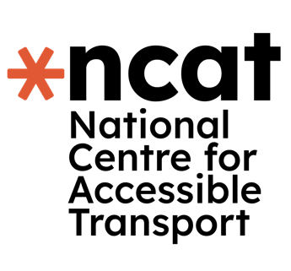

**This report is part of a series of research conducted by the National Centre for Accessible Transport (ncat) since its launch as an Evidence Centre in early 2023. Whilst this is a standalone report, we would recommend it is considered alongside other ncat research published from late 2024. As ncat progresses further, reports and insights will also be published on our website:** [**www.ncat.uk**](http://www.ncat.uk)

**ncat encourage you to freely use the data available in this report for your research, analyses, and publications. When using this data, please reference it as follows to acknowledge ncat as the source:**

**ncat (2024). ‘The barriers to streetscape access’. Available at**[**www.ncat.uk**](https://wsp-uk.shinyapps.io/ncat_dashboard/www.ncat.uk)

## Why did we do this work?

**Disabled people face significant barriers in participating in society, reporting higher anxiety, limited access to education and lower employment prospects than a non-disabled person [1]. Streetscapes are broadly defined as all the aspects that create a street. This can include the pavements, trees, benches, bins, public art, lampposts etc.**

**Every journey, for any reason, starts with a disabled person leaving the house and directly interacting with their local streetscape. If these first steps are inaccessible, then it can lead to a journey not being taken at all. Accessible streetscapes are key to enabling the independent movement of disabled people, and yet, several significant barriers exist.**

**These streetscape barriers must be addressed so that we can move towards a more accessible society for all. But to date, there has been little work that has involved disabled people in mapping the entire streetscape experience, and the impact it has on a disabled person’s life.**

**Therefore, we did this work to ensure that disabled people’s experiences are captured, and actions to improve accessibility can be prioritised and mapped. This will then give us the opportunity to take the critical steps to improve street access for all disabled people.**

## 2 What did we do, how did we do it, and who did we work with?

**The aim of this investigation was to:**

1. **Understand the barriers disabled people face when using the streetscape.**
2. **Understand why changes are not being made to the streetscape**
3. **What the impact on a disabled person’s life is because of the inaccessible streets**
4. **Prioritise the actions that should be made to improve the streetscape.**

**We took a two-step approach to ensure we understood the barriers in the streetscape. First, we conducted interviews with 26 disabled people from around the UK. Each interview was around 40-60 minutes long and could be conducted either over the phone, on Microsoft Teams or on Zoom, at the interviewee’s preference.**

**Then we sent out an online survey which was completed by 408 disabled people. The online survey could be completed by phone or video relay. The survey took around 15-20 minutes to complete. The survey was designed to be accessible.**

**In both studies, we asked disabled people about:**

* **their experiences of using the streetscape**
* **the biggest barriers they faced**
* **what happened when they contacted their local authority**
* **how the streetscape is changing and how it affects the journeys made.**

**For both studies, we engaged with our panel, called the Community of Accessible Transport (CAT). The panel had been developed to allow disabled people to be involved in shaping the future of transport, to share ideas, learn from others and find solutions that work.**

3 What did we find from the interviews?

**The results from both studies are presented below, starting first the results from the interview study.**

### **Overall Themes**

**Four key themes were clear from the interviews:**

1. **Exhaustion. There was a recurrent theme of disabled people feeling exhausted. Disabled people told us that participation in society was draining. Several disabled people were quoted as saying that they had to ‘pick their battles’ in society; for example, whether they placed their energy into campaigning to try to get street improved or put their energy into just navigating the streets. The exhaustion mostly came from a range of issues around the design of streets, public behaviours and attitudes and the complexities of planning their journeys.**
2. **Unpredictability. The major cause of anxiety and difficulties in the streetscape is the unpredictability of the experience. Unexpected events in the streetscape are common, such as roadworks, public behaviours on streets, the standard of facilities (such as toilets) as well as the differences in design and standards across different cities in the UK. Better communication of potential changes and disruptions to the streetscape was highlighted by disabled people as a key improvement here.**
3. **Invisibility. Disabled people felt that their needs were not considered across society. Especially with the development of new infrastructure and areas, where there was no engagement with disabled people and consequently were designed inappropriately. More fundamentally, the feeling of invisibility contributed strongly to feelings of exhaustion and the following theme.**
4. **Burden of adjusting for society. Disabled people felt the onus was on them to adapt to society, rather than their needs being considered and proactively designed for. Across all aspects of accessing streets, such as street design, complaints to local councils and planning their journey, there was this reoccurring theme that it was their responsibility to make their travels and needs work for them.**

**Here is a summary of everything that people told us from our interviews:**

1. **The ways in which society is designed is bad for accessibility**
2. **Pavements pose numerous barriers**
3. **Behaviour from the public increases risks and barriers**
4. **Street furniture pose unpredictable barriers**
5. **Navigating the streetscape is time-consuming and challenging**
6. **Roadworks add to the unpredictability of streets**
7. **Street design negatively impacts disabled people’s navigation, health and behaviour**
8. **Issues are not being addressed and communication is poor**
9. **New modes of transport are creating concerning trends for the future of streets.**

4 What did we find from the questionnaire?

**From the 26 interviews conducted, we took the key results and used them to then develop a questionnaire. Following the advanced statistical modelling of the results, we found that the following factors have the most significant impact on a disabled person’ life (in this order):**

1. **Pavement needs**
2. **Street furniture**
3. **Previous experiences of streetscape barriers**
4. **Local Authorities**
5. **Roadworks**

**These are out findings from the statistical analysis of the questionnaire. However, we acknowledge that some items that were removed may still hold importance for individuals. For these items, we will continue to investigate their impact in future work.**

5 What conclusions did we come to?

**The interviews highlight the significant barriers disabled people face in accessing UK streetscapes. We developed the following principles for streetscape accessibility, by bringing together all of the findings, themes and gaps identified.**

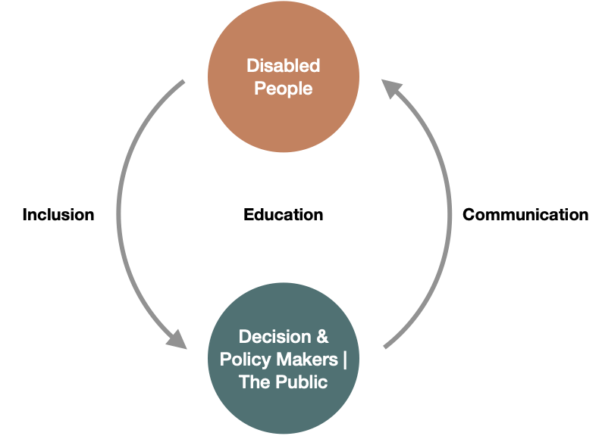

**Figure 1 Summary of Streetscape Work**

**Inclusion: Addressing many of the barriers disabled people face requires gathering their input and translating it into action. A cultural shift is needed to ensure disabled people are actively involved in key decisions about infrastructure, public spaces, and policy.**

**Communication: Poor communication from decision-makers to disabled people, especially regarding Local Authorities, adds to the barriers. While participants recognized the limits on addressing every issue, better communication would significantly help.**

**Education: Education underpins both inclusion and communication. Many issues, such as unsafe e-scooter use or poorly placed street furniture, arise from a lack of awareness. Policy and design must focus on educating people to better understand the impact of their actions.**

**There is a critical need for accessible streetscapes. Disabled people in both studies reported challenges accessing key areas of society due to poor street design. Common themes include exhaustion, unpredictability, invisibility, and the burden of adapting to an inaccessible environment.**

**Failures occur at every stage of streetscape development. From the start, disabled people are not adequately consulted during design, as reflected in interviews and the questionnaire. Maintenance is also a concern, with poorly kept pavements and inadequate temporary paths during roadworks. When issues are reported, disabled people often feel dismissed, and no changes follow their complaints.**

**The study demonstrates that inaccessible streetscapes have a profound impact on the lives of disabled people, and current practices are insufficient to address these issues.**

## 6 What should happen next?

**Based on this extensive study the following recommendations are put forward:**

* **Local Authorities and urban developers must critically prioritise the maintenance and improvement of pavement surfaces around the UK. Particularly in the areas around key points of interest, such as GP practices, high streets and shops.**
* **The inclusion of disabled people in the design of new street spaces must be included in legislation for any new urban development and this must be regulated by a governing body so that Local Authorities and urban developers are held accountable.**
* **Where facilities, (such as toilets and disabled seating) for disabled people have been provided, there must be adequate maintenance of them to ensure they remain in a condition fit for use.**
* **Reporting issues to Local Authorities needs a fundamental overhaul, with significant changes needed in how feedback from disabled people is handled. There must be transparency in what happens to a complaint and an obligation for the local authority to provide a response.**
* **The formation of an accessible streets ombudsman, capable of taking responsibility for ensuring complaints and feedback from disabled people are processed appropriately. This body would be the central contact point for disabled people to raise concerns with, addressing the issue of feeling invisible and not having a representative body to talk to.**
* **Develop new standards around the provision of temporary paths and ramps at roadworks and ensure this is enforced in legislation, to ensure that paths remain accessible. Furthermore, residents should be notified of disruptions in their local area, so that they may plan around this before coming across the works in the streetscape.**
* **The Government and Local Authorities should run public awareness campaigns to increase awareness and knowledge around disabled people’s needs to begin the process of changing behaviours that lead to problems like pavement parking and poor placement of advertising boards.**

### **Recommendations are also taken up by ncat for its future activities, where ncat will:**

* **use and share these findings to inform future research in conjunction with priorities identified through the voices and experiences of disabled people**
* **work with partners and stakeholders to make these findings available for them to use to robustly evidence the issues faced by disabled people when accessing transport**
* **work with policy makers, transport providers and industry to translate these findings to influence future policy and to develop solutions, products and services to reduce the transport accessibility gap.**

## 7 About ncat

**The National Centre for Accessible Transport (ncat) works as an Evidence Centre developing high quality evidence, best practice, and innovative solutions to inform future disability and transport strategy, policy, and practice by:**

* **Engaging with disabled people to better understand their experiences and co-design solutions**
* **Amplifying the voices of disabled people in all decision making**
* **Collaborating widely with all transport stakeholders**
* **Demonstrating good practice and impact to influence policy.**

**ncat is delivered by a consortium of organisations that includes Coventry University, Policy Connect, The Research Institute for Disabled Consumers (RiDC), Designability, Connected Places Catapult, and WSP. It is funded for seven years from 2023 by the Motability Foundation.**

**For more information about ncat and its work please visit** [**www.ncat.uk**](http://www.ncat.uk)

**To contact ncat, either about this report or any other query, please email** [**info@ncat.uk**](mailto:info@ncat.uk)



1. [Office for National Statistics (ONS). (2022). Outcomes for disabled people in the UK: 2021](https://www.ons.gov.uk/peoplepopulationandcommunity/healthandsocialcare/disability/articles/outcomesfordisabledpeopleintheuk/2021)