**The Barriers to Streetscape Access**

A two-part investigation into identifying and modelling

the most impactful

streetscape barriers

Full Report, November 2024

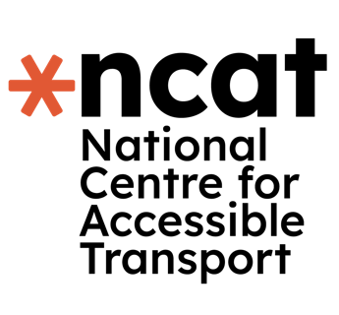

This report is part of a series of research conducted by the National Centre for Accessible Transport (ncat) since its launch as an Evidence Centre in early 2023. Whilst this is a standalone report, we would recommend it is considered alongside other ncat research published from late 2024. As ncat progresses further, reports and insights will also be published on our website [www.ncat.uk](http://www.ncat.uk)

ncat encourage you to freely use the data available in this report for your research, analyses, and publications. When using this data, please reference it as follows to acknowledge ncat as the source:

ncat (2024). ‘The barriers to streetscape access’. Available at [www.ncat.uk](https://wsp-uk.shinyapps.io/ncat_dashboard/www.ncat.uk)

Highlights

**This two-part study investigates the barriers to streetscape access for disabled people in the UK.**

The pavements, streets and paths that make up our outdoor environment are critical in allowing people to move with freedom, exercise and access critical parts of society, such as GP practices, shops and social locations. However, streetscapes have been shown to be inaccessible across a range of measures, which have significant impacts on disabled people’s lives. The work has shown the critical importance of involving disabled people in decision making; has highlighted significant deficiencies in the way in which complaints are handled by local authorities and shown the negative impact on disabled people because of these challenges. This work is the first to provide a statistically validated and prioritised list of recommendations based on the combination of two studies.

**Contents**

1 Why did we do this work? 3

2 What did we do, how did we do it, and who did we work with? 4

3 What did we find from the interviews? 7

Overall Themes 7

The design of society is bad for accessibility 8

Pavements pose numerous barriers 9

The behaviour from the public increases risks and barriers 9

Street furniture continues to pose unpredictable barriers 10

Navigating the streetscape is time consuming and challenging 10

Roadworks add to the unpredictability of streets 11

Streets negatively impact disabled people’s navigation, health and behaviour 11

Issues are not being addressed and communication is poor 12

New modes of transport are creating concerning trends for the future of streets 13

4 What did we find from the questionnaire? 14

Pavement Needs 15

Street Furniture 16

Previous experience of streetscape barriers 16

Local authorities 17

Roadworks 17

Impact on Life 17

5 What conclusions did we come to? 19

6 What should happen next? 22

7 About ncat 24

8 Appendices 25

## 1 Why did we do this work?

Disabled people face significant barriers in participating in society, reporting higher anxiety, limited access to education and lower employment prospects than a non-disabled person. Central to these impacts is the failure of urban streetscape design to enable the independent movement of disabled people.

When we talk about the streetscape, we mean all of the things that make up the outdoor environment, such as pavements, benches, trees, electrical cupboards, parked cars, and more.

These barriers of the streetscape must be addressed so that we can move towards a more accessible society for all. We did this work so that we can engage with disabled people to make clear recommendations to change policy and practice. This places disabled people at the heart of the decision making, something which has been missing in the street design work that’s happened so far.

2 What did we do, how did we do it, and who did we work with?

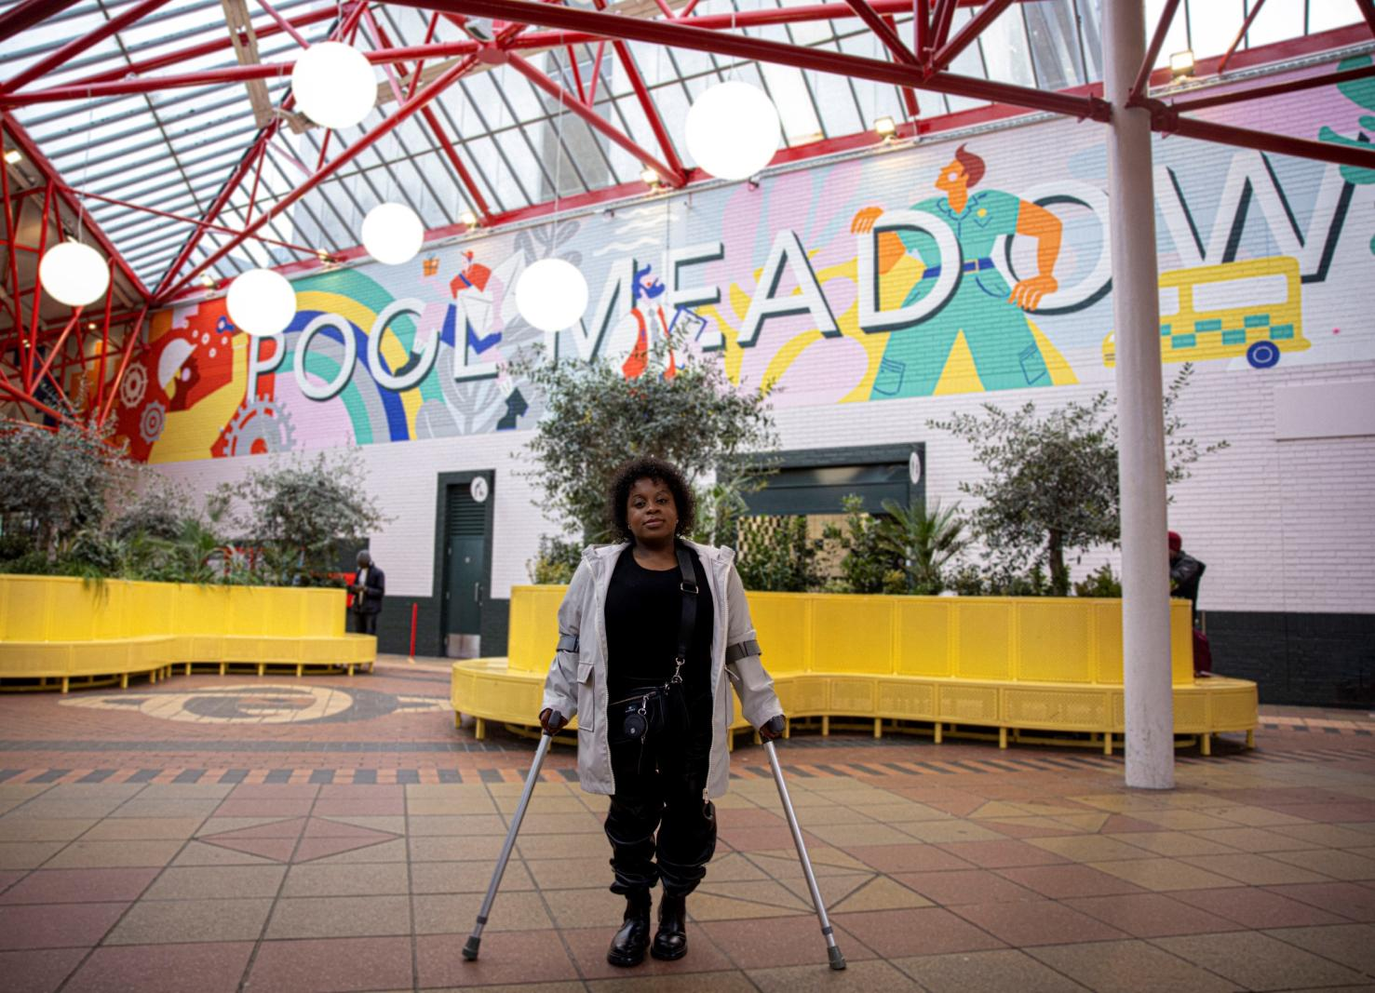

Image - (c) ncat

The aim of this investigation was to:

1. Understand the **barriers** disabled people face when using the streetscape.
2. Understand **why changes are not being made** to the streetscape
3. What the **impact** on a disabled person’s life is because of the inaccessible streets
4. **Prioritise** the actions that should be made to improve the streetscape

We took a **two-step approach** to ensure we understood the barriers in the streetscape. First, we conducted **interviews** with 26 disabled people from around the UK. Each interview was around 40-60 minutes long and could be conducted either over the phone, on Microsoft Teams or on Zoom, at the interviewee’s preference.

Then we sent out an **online survey** which was completed by 408 disabled people. The online survey was facilitated by the Research Institute for Disabled Consumers (RiDC) and could be completed by phone or video relay. The survey took around 15-20 minutes to complete. The survey was carefully designed to ensure the questions, its design and the online platform were all accessible.

In both studies, we asked disabled people about:

* their experiences of using the streetscape
* the biggest barriers they faced
* what happened when they contacted their local authority
* how the streetscape is changing and how it affects the journeys made

For both studies, we engaged with ncat’s Community of Accessible Transport (CAT) panel. A detailed breakdown of the people who took part in both studies can be found in the Appendix.

### **How did we analyse the results?**

The data collected from both studies was analysed using advanced techniques to ensure that the results are a fair and true representation of what disabled people told us.

Study 1, the interview study, was analysed using a process called thematic analysis. This lets us find the most important ideas and statements from the interviews. From the transcripts of interviews, we condense this down into chunks of data which let us find the most important ‘themes’. These themes represent the core ideas from the interviews.

Study 2, the online questionnaire, was analysed using an advanced statistical method known as structural equation modelling. This method is commonly used in decision and policy making. This enabled us to statistically rank the streetscape barriers based on their impact on a disabled person’ life. This is the first analysis of its kind for street accessibility, particularly using this method.

Using a combination of an interview study and an online questionnaire analysed using an advanced statistical modelling technique, we could create a list of actionable recommendations for the streetscape, with the intention to ensure the steps can be taken to begin implementing these recommendations.

3 What did we find from the interviews?

The results from both studies are presented below, starting first the results from the interview study.

### **Overall Themes**

Four key themes were clear in the interview results:

1. **Exhaustion**. There was a recurrent theme of disabled people feeling exhausted throughout all the streetscape barriers and challenges raised. Disabled people told us that participation in society was draining. Several disabled people were quoted as saying that they had to ‘pick their battles’ in society; for example, whether they placed their energy into activism and trying to make a change in street design or put their energy into just navigating the streets. This primarily stemmed from a range of issues around the design of streets, public behaviours and attitudes and the complexities of planning their journeys.
2. **Unpredictability**. The major cause of anxiety and difficulties in the streetscape is the unpredictability of the experience. Unexpected events in the streetscape are common, such as roadworks, public behaviours on streets, the standard of facilities as well as the differences in design and standards across different cities in the UK. Better communication of potential changes and disruptions to the streetscape was highlighted by disabled people as a key improvement which could address this theme.
3. **Invisibility**. Disabled people felt that their needs were not considered across society. Especially with the development of new infrastructure and areas, which often lacked engagement with disabled people and consequently were designed inappropriately. More fundamentally, the feeling of invisibility contributed strongly to feelings of exhaustion and the following theme.
4. **Burden of adjusting for society**. Disabled people felt the onus was on them to adapt to society, rather than their needs being considered and proactively designed for. Across all aspects of accessing streets, such as street design, complaints to local councils and planning their journey, there was this reoccurring theme that it was their responsibility to make their travels and needs work for them.

Now let’s look at the more detailed results from the interview study. Here is a summary:

1. The ways in which society is designed is bad for accessibility
2. Pavement pose numerous barriers
3. Behaviour from the public increases risks and barriers
4. Street furniture continue to pose unpredictable barriers
5. Navigating the streetscape is time-consuming and challenging
6. Roadworks add to the unpredictability of streets
7. Street design negatively impact disabled people’s navigation, health and behaviour
8. Issues are not being addressed and communication is poor
9. New modes of transport are creating concerning trends for the future of streets

We’ll talk about these in more detail now:

### **The design of society is bad for accessibility**

The largest issue within the streetscape challenges group was societal design. Disabled people highlighted inadequate consideration of their needs, resulting in inconsistent design and implementation across the country. Streetscape installations often overlook disabled people’s needs. One disabled person noted, “*I don’t think they [Local Authorities] think enough about the positioning of it at times… The street signs themselves are a […] nuisance*” (P26 | Carer). Facilities like disabled parking spaces were also seen as inadequate, “*Why would you put a whole road of disabled spaces… and then there’s no dropped kerb nearby?*” (P6 | Powered wheelchair, mobility). Additionally, new designs sometimes worsened accessibility, as another disabled person observed, “*They seem to have then lost all of the crossing points that were previously there*” (P3 | Powered wheelchair, mobility).

### **Pavements pose numerous barriers**

Pavements were the second most common streetscape challenge. Disabled people frequently mentioned poor pavement surfaces causing pain, inconvenience, or making paths impassable. The scarcity and positioning of dropped kerbs, along with pavement camber, were key concerns. One disabled person noted how these issues only became apparent after using a wheelchair: “*Oh my goodness, these are things that you don’t realise are there until you start using wheeled things on. The camber fools you*” (P17 | Powered wheelchair, mobility). Shared spaces were also problematic, creating anxiety over road priorities. Additionally, the group pointed out poor maintenance, inconsistent surfaces, tree root damage, and weather effects. One disabled person remarked, “*There are so many bad ones… very few… I can easily navigate, but there are so many that are broken or they don’t have much textile*” (P17 | White cane, visual impairment).

### **The behaviour from the public increases risks and barriers**

Public behaviours negatively impacting disabled people in streetscapes. Pavement parking was the most significant challenge, making street navigation difficult. One disabled person preferred traveling on the road due to this issue: “*It’s safer for me to go onto the road than it is to actually approach somebody directly now because of the mentality*” (P11 | Crutches, Mobility). Disabled people also reported aggression from the public and frequent collisions with distracted pedestrians, often on their phones: “*I think it’s probably 80 percent people being on their phones… I’ve had people put their hand on me and push me out of the way*” (P15 | White cane, visual impairment).

### **Street furniture continues to pose unpredictable barriers**

Street furniture was frequently mentioned as a barrier for disabled people navigating streets. Bins, especially after collection, were highlighted as the most common issue. Some noted that bins were often left out by residents: “*Wheelie bins are a nightmare… they’re out in the streets on collection days, but some people keep them out there*” (P2 | Powered wheelchair, mobility impairment). The unpredictability of street furniture, like dining tables and chairs placed outside later in the day, also made navigation difficult: “*Street furniture… may all of a sudden be changed or moved so you have to find more reliable landmarks*” (P9 | White cane, visual and hearing impairment). Advertising boards were another frequent obstacle, with their awkward shapes adding to the challenge.

### **Navigating the streetscape is time consuming and challenging**

The main concern was that accessible routes were often longer and less convenient than non-accessible ones. Notably, twice as many comments came from people with visual impairments. One participant explained, *“…to reach one of the bus stops, it’s only going to take five minutes and I’ll be choosing the 20 minutes way, because I know the other way, there are not many barriers*” (P5 | White cane, visual impairment). Some also noted the lack of contrasting colours, making it hard to distinguish crossings, kerbs, or cycle lanes. The zig-zag design of certain crossings, where a central refuge island forces multiple crossings, was another example of design that failed to consider disabled people’s needs.

### **Roadworks add to the unpredictability of streets**

Disabled people described difficulties navigating temporary paths. One participant shared, “*They might have like taped off areas around the holes. I just find that really quite scary, because as I’m approaching, I can never really know what is going on until I get really, really close*” (P14 | White cane, visual impairment). Missing or incorrectly designed ramps, often too steep, were also a common issue. Participants acknowledged the necessity of roadworks but emphasized that better communication about them would help disabled people prepare for the disruptions, highlighting the unpredictability of such situations.

### **Streets negatively impact disabled people’s navigation, health and behaviour**

A major impact for disabled people was being forced onto the road due to inaccessible pavements, increasing anxiety and risk. Journeys often took longer, and unexpected barriers sometimes forced them to turn back. One disabled person shared, “*There are times when I’ve tried to get out, but I can’t get past the cars with the drop kerbs so I’ve just gone home again*” (P6 | Powered wheelchair, mobility impairment). Some disabled people avoid certain areas entirely and resort to more expensive transport, such as taxis.

Streetscape challenges required disabled people to exert more physical and mental effort, often resulting in pain or injury. One disabled person expressed, “*It is awful and you have to have a high level of physical and emotional resilience… There are days when I feel far less resilient… it’s exhausting*” (P15 | White cane, visual impairment). These challenges were especially prevalent for those with visual impairments.

Streetscape barriers led disabled people to limit outdoor activities, as reflected in the literature. One person explained, “*I’ve got late lectures… I could really do with just quickly running into town… but I’m like, ‘Oh, I’m not going to be able to park, I’m going to have to put that off for another day’*” (P10 | Crutches, mobility). Some disabled people had to wait for others to help them continue their journey.

### **Issues are not being addressed and communication is poor**

Disabled people were asked about their experiences raising streetscape challenges with local authorities. In all cases, complaints were directed to the relevant local councils.

Most disabled people described the complaint process as time-consuming and exhausting. One participant noted, “*A lot of people don’t want to complain… They feel they’re going to be a troublemaker*” (P18 | Manual wheelchair, mobility impairment), while another said, “*I’ve written to the local council about so many things I can’t keep up with it now*” (P14 | White cane, visual impairment). Many felt there was little engagement from authorities, leaving them unsure of what happened to their complaints, which discouraged further reporting.

For those who did complain, most saw no action. While some initially received engagement from the local authority, progress often stalled: “*I felt like I was getting somewhere… but then nothing happened*” (P4 | Manual wheelchair, mobility impairment). Many felt their complaints were dismissed, with one participant saying, “*I don’t know if I’ve been listened to… it’s just like a tick box exercise*” (P9 | White cane, visual impairment). This lack of response reinforced the perception that the process was tiring and ineffective.

### **New modes of transport are creating concerning trends for the future of streets**

Concerns about electric vehicles were infrequent, mainly because they are still relatively uncommon. However, many disabled people mentioned the difficulty in hearing them approach: “*Too quiet. I haven’t got the best hearing and I’ve nearly been run over a number of times*” (P18 | Manual wheelchair, mobility impairment). This raises questions about the adequacy of current regulations on electric vehicle noise, which requires them to emit at least 56 dB at low speeds (EU Regulation 540/2014, UNECE Regulation No. 138). Despite this rule, more research may be needed to ensure the sounds are distinguishable from other street noise. Some participants mentioned encountering electric vehicle charging cables on pavements, but this was rare due to the low number of electric vehicles: “*I’ve not personally come across that… most people have got driveways, so their cars are on driveways*” (P3 | Powered wheelchair, mobility impairment).

Disabled people were overwhelmingly negative about scooters and bikes on pavements, particularly e-scooters. Many cited dangerous riding behaviours, “*People riding them on the pavement… I’ve been knocked over a few times. I’ve been clipped and had the living daylights terrified out of me and my guide dog*” (P15 | White cane, visual impairment). Participants also noted issues with scooters and bikes being left haphazardly on pavements and felt the lack of enforcement contributed to the problem, again placing the burden on disabled people to adapt.

This concludes the results of the streetscape interviews. The wide ranging results provided significant insight into the breadth of issues faced when accessing the streetscape. Further, the impacts and consequent issues have highlighted key systematic issues in the way complaints and feedback are handled.

In the next section, the results from the streetscape questionnaire will be discussed.

4 What did we find from the questionnaire?

We took all the findings from the interviews into the questionnaire. Following the advanced statistical modelling of the results, we found that the following factors have the most **significant** **impact** on a disabled person’ life (listed in order of the strength of their effect):

1. Pavement needs
2. Street furniture
3. Previous experiences of streetscape barriers
4. Local authorities
5. Roadworks

Note, that significant impact is measured statistically. This means the factors of e-scooters, public behaviours and information about streets were all found to be **statistically insignificant**. These are the results from this survey’s statistical analysis and further work will be required to explore why these were not found to be significant. While some results have been deemed statistically insignificant, we acknowledge that they may still hold importance for individuals. However, for the purposes of this report, only those findings that meet the threshold for statistical significance will be discussed.

Now each of these factors will be looked at in more detail, starting with pavement needs.

### **Pavement Needs**

This factor encompassed questions in the questionnaire regarding both the physical design aspects of pavements, as well as perceptions as to whether disabled people’s needs are considered in the design of pavements. Notably, the most significant impact on life for a disabled person were the perceptions as to whether they felt their pavement needs were being considered. The overwhelming opinion was that disabled people felt their needs weren’t considered in the design of pavements, indicated by 75.6% of respondents. The response was more negative when asked specifically about whether they felt local authorities consider their needs. From the interviews, the theme of invisibility strongly relates to these results and highlights the importance of needing to engage appropriately and effectively with disabled people as this has a significant impact on their lives. Following this, the pavement surface quality, camber and width had the biggest impacts on pavement needs and therefore their lives, with around 87% of disabled people indicating they strongly agreed that their needs were not met.

### **Street Furniture**

Street furniture was the next significant streetscape related impact on a disabled persons life. The largest effect was from advertising boards on the street and pavement parking. Around 65% of respondents said they have challenges navigating around cars park on the pavement. Both were prevalent in the interview study, relating to the themes of unpredictability and the burden of adjusting to society. Similarly positioned with regards to their impact were outdoor dining, wheelie bins and overgrown hedges. With specific regards to wheelie bins, 85% of respondents said they were worse after they had been collected. These relate strongly to public behaviours and awareness, with the core of the barriers addressed if there was better education and action over disabled people’s needs.

### **Previous experience of streetscape barriers**

The most impactful experience on this factor were occasions when a person would have to return down a path because of inaccessible pavements impeding their journey. 92% of respondents said they had an experience of having to return down a path because of a barrier in the streetscape. This was followed by the alternative action that disabled people described, which was to travel on the vehicle road surface instead of the pavements. 97% of respondents said they had an experience of having to travel on the road because of inaccessible pavements. It should be considered that all of the other factors, such as pavement needs, contribute to these previous experiences of barriers, meaning that when the streetscape fails to be accessible it has a lasting impact on a person, beyond that single experience.

### **Local authorities**

This factor investigated one of the main ideas from the interview study around the challenges in reporting streetscape issues to the local authority. The largest impact on this factor was the feeling that local authorities do not listen to or hear disabled people’s needs. 62% of respondents felt they did not feel heard by their local authority. Following this, what happens with feedback was another issue that was raised in the interviews and in this survey, 63% of disabled people said they did not know what happens to feedback after contacting their local authority.

### **Roadworks**

Like the interview study, the survey sound that temporary paths and ramps were the most influential factors regarding roadworks, which consequently have a negative impact on disabled people’s lives. 94% of respondents indicated they had challenges navigating the temporary paths around roadworks, with 84% highlighting the temporary ramps as challenging.

### **Impact on Life**

The most significant impact was shopping less as a result, with 80% of surveyed respondents indicating as such. There were also negative impacts on socialising and an increase in worry about being injured or hurt because of the street designs. All disabled people said they avoid certain areas in their area because of inaccessible streets, with 52% saying they avoid certain towns and cities as a result.

The previous sections have described the results from this two-part study in detail. The combination of both qualitative and quantitative methods providing deeper insights into the barriers faced by disabled people.

5 What conclusions did we come to?

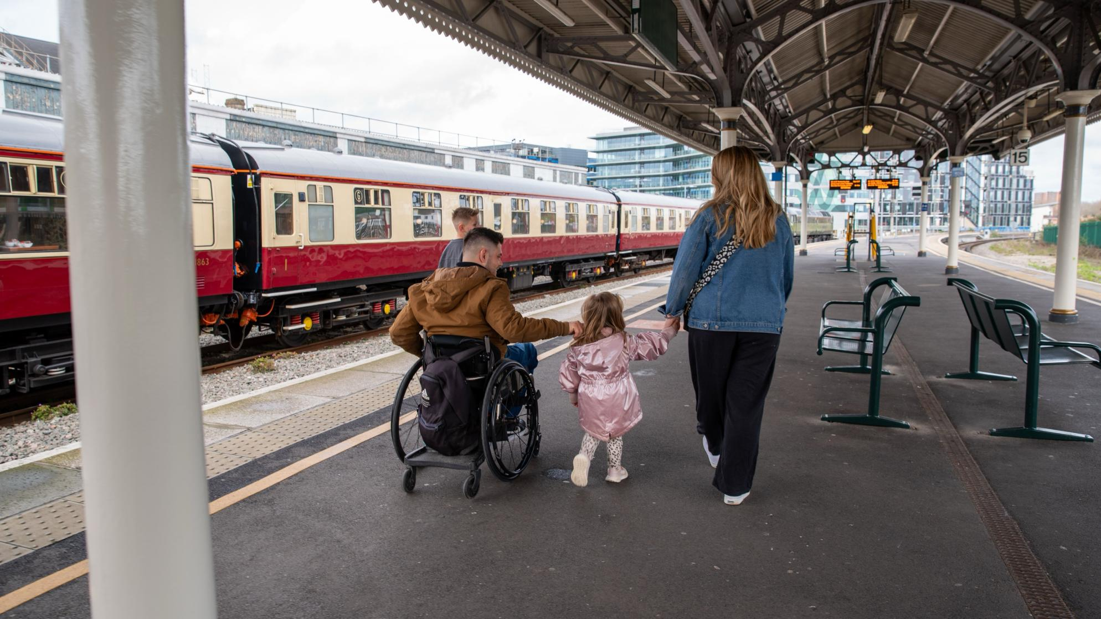

Image - (c) ncat

The interviews highlight the significant barriers disabled people face in accessing UK streetscapes. Several findings, not yet covered in published research, prompted the researchers to explore potential solutions. Based on the themes and gaps identified, the following principles for streetscape accessibility have been developed.

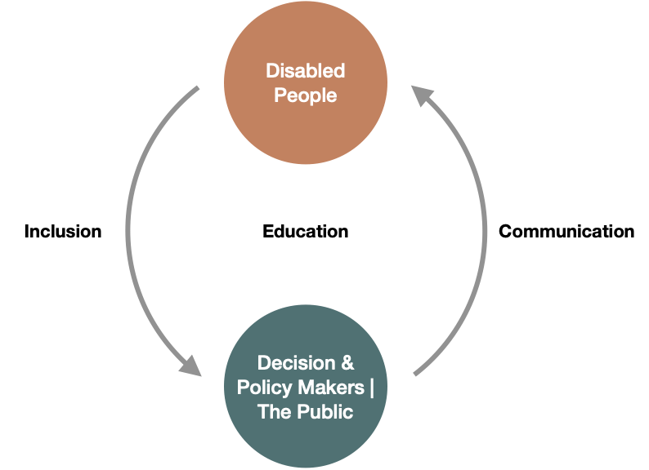

Figure Summary of Streetscape Work

* **Inclusion**: Addressing many of the barriers disabled people face requires gathering their input and translating it into action. A cultural shift is needed to ensure disabled people are actively involved in key decisions about infrastructure, public spaces, and policy.
* **Communication**: Poor communication from decision-makers to disabled people, especially regarding local authorities, adds to the barriers. While participants recognized the limits on addressing every issue, better communication would significantly help.
* **Education**: Education underpins both inclusion and communication. Many issues, such as unsafe e-scooter use or poorly placed street furniture, arise from a lack of awareness. Policy and design must focus on educating people to better understand the impact of their actions.

This analysis underscores the critical need for accessible streetscapes. Disabled people in both studies reported challenges accessing key areas of society due to poor street design. Common themes include exhaustion, unpredictability, invisibility, and the burden of adapting to an inaccessible environment.

Failures occur at every stage of streetscape development. From the start, disabled people are not adequately consulted during design, as reflected in interviews and a statistical model showing poor perceptions of local authorities and designers. Maintenance is also a concern, with poorly kept pavements and inadequate temporary paths during roadworks. When issues are reported, disabled people often feel dismissed, and no changes follow their complaints.

The study demonstrates that inaccessible streetscapes have a profound impact on the lives of disabled people, and current practices are insufficient to address these issues. A statistically validated prioritisation of key factors needing improvement includes:

1. Pavement conditions

2. Street furniture

3. Past experiences with streetscape barriers

4. Local authorities’ actions

5. Roadworks

These barriers result in disabled people feeling exhausted by constant obstacles, anxious due to the unpredictability of streets, invisible when their concerns are ignored, and burdened by having to adapt to a society that fails to meet their needs.

## 6 What should happen next?

Based on this extensive study the following recommendations are put forward:

* Critically prioritise the maintenance and improvement of **pavement surfaces** around the UK. Particularly in the areas around key points of interest, such as GP practices, high streets and shops.
* Legislate the **inclusion of disabled people** in the design of new street spaces and regulate so that action is taken on feedback.
* Where facilities for disabled people have been provided, there must be **adequate maintenance** of them to ensure they remain in a condition fit for use.
* **Reporting issues to local authorities need a fundamental overhaul**, with significant changes needed in processing the feedback and providing stronger communications regarding actions to be taken.
* The formation of an **accessible streets ombudsman**, capable for taking responsibility for ensuring complaints and feedback from disabled people are processed appropriately.
* Legislate standards around the **provision of temporary paths and ramps at roadworks** to ensure that paths remain accessible. Furthermore, residents should be notified of disruptions in their local area, so that they may plan around this before coming across the works in the streetscape.
* Run **public awareness campaigns** to increase awareness and knowledge around disabled people’s needs to begin the process of changing behaviours that lead to problems like pavement parking and poor placement of advertising boards.

The findings will be used in two ways. First, the key recommendations made, as well as the results, provide critical actions that must be undertaken to improve disabled people’s access and lives. Second, the development of the novel model of streetscape barriers using advanced statistical analysis has provided a form of prioritisation of issues. For example, through the analysis, the quality of pavements was found to have the biggest impact on disabled people’s lives; therefore should be acted on first. This prioritisation is of great value, particularly when planning the implementation of such recommendations.

The findings will be disseminated across a range of audiences in industry, government and academia. The aim is to raise awareness and build a group of influential parties who can begin the process of bringing these recommendations to policy. A powerful next step would involve close collaborations with a local authority to implement and test the recommendations in a real-world setting, to demonstrate and quantify the benefits.

## 7 About ncat

The National Centre for Accessible Transport works to ensure that no disabled person faces challenges arising from poor access to transport. ncat aims to deliver on this mission by:

* Engaging with disabled people to better understand their experiences and co-design solutions
* Amplifying the voices of disabled people in all decision making
* Collaborating widely with all transport stakeholders
* Demonstrating good practice and impact to influence policy

ncat is delivered by a consortium of organisations that includes Coventry University, Policy Connect, The Research Institute for Disabled Consumers (RiDC), Designability, Connected Places Catapult, and WSP. It is funded for seven years from 2023 by the Motability Foundation.

For more information about ncat and its work please visit [www.ncat.uk](http://www.ncat.uk)

To contact ncat, either about this report or any other query, please email [info@ncat.uk](mailto:info@ncat.uk)



## 8 Appendices

#### **Table 1. Demographics of disabled people who participated in the interviews**

|  |  |
| --- | --- |
| **Category** | **Breakdown** |
| Age | 18-30 (1), 31-40 (6), 41-50(5), 51-60(8), 61-70(3), 70+(3) |
| Gender | Female(20), Male(6) |
| Disability | Mental health (5), Memory (9), Non-visible (10), Continence (10), Vision (14), Specific learning difficulty (6), Learning disability (4), Social/behavioural (e.g., Autism/ADHD) (7), Mobility (19), Hearing (8), Diet (2), Dexterity (9), Communication (5), Stamina (1) |
| Aids | Cane(7), Crutches/walking stick(9), Guide dog(2), Wheelchair- manual(4), Wheelchair- powered(8) |

#### **Table 2. Demographics of disabled people who participated in the online questionnaire study**

|  |  |
| --- | --- |
| **Category** | **Breakdown** |
| Gender | F(224), M(169), N(6), Prefer not (9) |
| Ethnicity | White (377), Black (7), Indian (3), Irish (4), Non-Brit Eur (1), Other Asian (4), Multiple (3), Pakistani (1), Prefer not (6) |
| Area | Urban (129), Suburban (185), Rural (81), Not Sure (11), Prefer not (2) |
| Region | East Midlands (25), East of England (25), Greater London (65), North East (13), North West (38), Northern Ireland (2), Other (11), Scotland (34), South East of England (60), South West (1), South West of England (39), Wales (18), West Midlands (35), Yorkshire and Humber (41) |
| Category | Disability charity/Community grp/ Higher Ed (47), Transport Sector (7), Both (4) |
| Travel Freq | A few times a month (27), A few times a week (175), A few times a year (9), Daily (171), Monthly (2), Weekly (23) |
| Companion | Alone (222), Carer/Assistant (46), Family/Friends (96), Other (Please specify) (43), Prefer not (1) |
| House | Bungalow (95), Detached house (62), Flat (89), Other (Please specify) (8), Semi-detached house (83), Terraced house (71) |
| Disability | Dexterity (1), Hearing (5), Learning (6), Memory (1), Mental (2), Mobility (353), None of the above (2), Social (2), Vision (35) |